CDTA COMMITTEE AGENDA

Performance Oversight Committee

December 07, 2016

Start Time: 12:00 pm; Anticipated End Time: 1:30 pm

110 Watervliet Avenue

Committee Item

Call to Order

Ascertain Quorum

Agenda Approval

Approve Minutes of October 18, 2016

Consent Agenda Items
- Approve Contract for Paratransit Dispatching Software (10 minutes)
- Approve Contract for Construction of River BRT Stations (5 minutes)
- Approve Contract for Purchase of Batteries (5 minutes)
- Approve Contract for Bike Share (10 minutes)

Audit Committee
- No Items Scheduled

Investment Committee
- Update on Committee Activities / Reports (5 minutes)

Administrative Discussion Items
- Fleet Inspection Annual Report (15 minutes)
- Risk Management & Workers’ Compensation Quarterly Report (5 minutes)
- Monthly Management Report (10 minutes) *
- Monthly Non-Financial Report (10 minutes) *

Executive Session
- Pending Litigation Report (5 minutes)
- Security Update Monthly Report (5 minutes)

For the Good of the Order

Next Meeting Date: January 18, 2017

Adjourn

* Indicates Material (Or Additional Material) Will Be Provided at Meeting



Capital District Transportation Authority
Performance Oversight Committee
Meeting Minutes – October 18, 2016 at 12:00 pm at 110 Watervliet Avenue

In Attendance
Georgie Lussier (acting Chair), Art Young, Joe Spairana, Corey Bixby, Carm Basile (CEO), Christopher Desany (CSL), Mike Collins, Amanda Avery, Lance Zarcone, Fred Gilliam, Rick Vines, Thomas Guggisberg, Jaime Watson, Jonathan Scherzer, Ross Farrell, Bridget Beelen, Phil Parella, Mark Wos, Kathy Colbert.

Meeting Purpose: Regular meeting of the Performance Oversight Committee

It was noted that a quorum was present. The minutes from the September 21, 2016 meeting were reviewed and approved.

Consent Agenda Items

Accept 10% State Share of Six Federal Grants
CDTA is apportioned Federal funds on an annual basis in support of our bus and bus facilities program through the Section 5307 program. These project costs are funded with 6 federal grants. These funds will be used to support the acquisition of fixed route buses, paratransit buses, articulated buses, commuter service between Albany and Ulster County, preventative maintenance, the bus shelter replacement program, passenger amenities, and design/engineering associated with BRT projects The New York State Department of Transportation requires a Board resolution to accept State funding prior to being reimbursed for expenses incurred as part of an agreement.

The Committee recommends accepting the 10% State match of federal funds in the amount of $2,790,035 as per agreement K007049

Audit Committee Items
No items scheduled.

Investment Committee Items
The Hugh Johnson Advisors report was distributed prior to the meeting and was accepted by the committee.

Administrative Discussion Items

Monthly Management (financial) Report
Mike Collins gave the monthly management report. Mortgage tax receipts exceeded budget expectations for the last three months and we are ahead of budget by 12% for the year. Customer fares have also been ahead of projections for the last three months. Wages were over budget by 2% for the month due to the new service, and workers’ compensation was over budget by 15% for the year. Purchased transportation was slightly over budget for the month, but under budget for the year. Liability-claims were down 37% for the month and 39% for the year. We are in a satisfactory cash flow position at this time.

We will be starting the budget process for FY18 beginning next month, and in January we will have a budget adjustment.

Monthly Non-Financial (performance) Report
Chris Desany gave the monthly non-financial report. Overall, measurements this month were positive. Total ridership was up 3.7% for the month. There were two PMI’s not on time, and missed trips were at 19 this month. MDBSI was at 45,208. Scheduled work was at 81%. There were 17 preventable and 21 non-preventable accidents, and 95% of customer complaints were closed within 10 days.

For The Good of the Order
No items scheduled.

Executive Session
No items scheduled.

Capital District Transportation Authority
Agenda Action Proposal

Subject: Sole Source Contract Award for Paratransit Dispatching Software to Trapeze Software Group, Inc. of Cedar Rapids, Iowa.

Committee: Performance Oversight
Committee Meeting Date: December 7, 2016
Board Action Date: December 14, 2016

Background:
The original Computer Aided Dispatch/Automatic Vehicle Location (CAD/AVL) system has reached the end of its useful life. A new system is required, including one that addresses CDTA’s paratransit being partially outsourced.

Purpose:
To provide a modern, reliable CAD/AVL system that allows for CDTA’s hybrid approach to paratransit that is customer focused.

Summary of Proposal:
A Request for Proposals (RFP) was issued for the procurement of an Intelligent Transportation Management System (ITMS) in April 2016. It became apparent during the proposal review and interview process that the paratransit offerings by Trapeze were more robust than their competitors and more able to meet CDTA’s needs in that area. Staff requested a technical approach and cost proposal to provide the paratransit functionality that was contained in their original proposal.

Thus, Trapeze provided a proposal for the design, furnishing, testing and installation of a paratransit CAD/AL system in a hybrid environment that enhances functionality for CDTA and customers (see attached memo of support for specifics). Through the larger ITMS procurement process Staff reviewed other paratransit CAD/AVL offerings and found them to be lacking the functionality of the Trapeze DriverMate solution. The sole source nature of this procurement is a result of the larger competitive ITMS RFP process. Staff finds pricing to be fair and reasonable based on the analysis from the ITMS RFP. Staff recommends a sole source contract for the term of two-years with three optional renewals be awarded to Trapeze Software Group, Inc. of Cedar Rapids, Iowa for an amount not to exceed $999,622 for a paratransit dispatching system.

Financial Summary and Source of Funds:
$843,668 for system implementation funded through the TIGER VI Grant
$155,954 for first two years of maintenance funded through FY17-18 Operating Budgets
Total: $999,622

Prepared by:
Stacy Sansky, Director of Procurement

Project Manager:
Christopher Desany, Vice President of Planning & Infrastructure

Date: December 07, 2016
To: Chairman, Performance Oversight Committee
Members, Performance Oversight Committee
From: Christopher Desany, Vice President of Planning and Infrastructure
Re: Recommendation for Paratransit Dispatching Software

Background
The original Computer Aided Dispatch / Automatic Vehicle Location (CAD/AVL) system was competitively procured and awarded in 2001. As of today, our systems (radio and CAD/AVL) have reached their end of useful life. Many components date back 20+ years, and coverage, reliability, and parts availability continue to be an issue. The timeline for the replacement of the system is as follows:

- October 2011: Began due diligence process of defining the objectives for new systems, as well as identifying detailed technical requirements.
- April 2014: Submitted an application to the Transportation Investment Generating Economic Recovery (TIGER) discretionary grant program, round VI, for funding to implement a radio and CAD/AVL replacement.
- August 2014: CDTA was awarded $18.5M in funding under the TIGER VI program.
- March 2015: Conducted request for information interviews.
- July 2015: Released RFP for P25 radio system. We decided to split the project into two solicitations, one for the radio system, and one for the ITMS upgrade. This agenda action item is only for the ITMS system.
- December 2015: Awarded P25 radio system contract to Motorola Solutions.
- April 2016: Released RFP for ITMS system.
- August 2016: Conducted ITMS interviews.
- September 2016: Awarded primary ITMS contract.

One of the primary goals of the ITMS scope was to leverage a “best of breed” approach to the project. As part of the solicitation process, all proposers recommended their own solution to addressing the requirements of our paratransit operations. As the Committee is aware, CDTA uses a distinctive “hybrid” approach to providing paratransit service, where a portion of the service is performed by CDTA staff and vehicles, and a portion is outsourced to a local transportation provider. This hybrid approach poses a unique set of challenges for implementing a customer focused CAD/AVL when a portion of the vehicles are not owned or maintained by CDTA.

As part of the ITMS solicitation, it was determined that Trapeze Group had the best solution to meet CDTA’s paratransit needs. Therefore, staff will be removing paratransit functionality from the scope of the ITMS contract awarded to INIT, and seeks to implement the Trapeze DriverMate paratransit solution as a partner project.

Therefore, CDTA requested a technical approach and cost proposal from Trapeze Software Group to provide for the paratransit functionality identified in the ITMS RFP.

Scope of Project
The scope specified the requirements for the design, furnishing, testing, and installation of a paratransit CAD/AVL system in a hybrid environment and included:
- Ability for supervisors to perform standard dispatching functions.
- Ability to allow customers to monitor the location of their vehicle and receive estimated time of arrival on their smartphone, tablet, or desktop computer.
- Ability to allow customers to view, create, update, and cancel trip information.
- Interactive Voice Response (IVR) functionality (via telephone) to review and cancel trips.
- IVR functionality to book trips from registered locations.
- Email and SMS notifications.
- Paratransit mobile dispatching, live and prescheduled.
- Mobile application that runs on tablet that operators use to receive manifests, turn-by-turn directions, track trip (arrivals, cancelled, no shows) and messaging.
- Providing a fully hosted central data system at a secure data center.

A summary of what is included in Trapeze’s proposal is as follows:
- Trapeze’s central data system solution:
  - Transit control system (desktop and mobile)
  - Customer facing mobile applications
  - Web portal
- Equipment and installation for 70 paratransit vehicles
- Configuration with existing scheduling system
- Project management, design, engineering, testing, training, documentation, and implementation services

Justification
Trapeze has extensive experience providing CAD/AVL solutions throughout the world since 1991. This sole source recommendation is based on the following:
- Trapeze has 1600 implementations in 16 countries.
- Trapeze reinvests 15% of revenue annually back into research and development.
- Trapeze has direct experience with a number of transit specific projects, for example:
  - Dallas Area Rapid Transit (DART), Dallas TX
  - Kansas City Area Transportation Authority (KCATA), Kansas City MO
  - Nashville Metropolitan Transit Authority (MTA), Nashville TN
  - Southwest Ohio Regional Transit Authority (SORTA), OH
  - Connecticut Transit, Hartford CT
  - Edmonton Transit System, Edmonton AB
  - Metropolitan Atlanta Rapid Transit Authority (MARTA), Atlanta GA
- Additionally, Trapeze DriverMate-only installations include:
  - San Diego Metropolitan Transit System (MTS), San Diego CA
  - Access Services, Los Angeles CA
  - Para Transpo, Ottawa CA
  - Las Vegas Veterans Services, Las Vegas NV
  - TheBus, Oahu HI
- The Trapeze solution will not require any integration with our existing paratransit scheduling software, as it is also provided by Trapeze and is part of the same platform.
- Trapeze is familiar with the many nuances of their existing scheduling system we have installed and its relationship to our requirements and therefore has full knowledge of CDTA needs.
- Utilizing this vendor will result in a zero net increase in vendors at CDTA.
- Utilizing this vendor will require no third-party integration or customization, which reduces the risk inherent in custom third-party vendor development.
- Pricing is the same or better than what was provided with the ITMS solicitation, and is consistent with the independent cost estimates.
- CDTA has reviewed the paratransit solutions from the six companies that provided responses to the ITMS solicitation.

Committee Action:
I am recommending that a two-year contract with three one-year extensions for a paratransit dispatching system be awarded to Trapeze Software Group, Inc. of Cedar Rapids, IA for a total amount not to exceed $843,667.50 for the system implementation (this includes a contingency), and $155,954 for the first two years of maintenance. Project implementation costs are funded by the TIGER VI grant, and maintenance costs will be funded under the operating budget.

CAPITAL DISTRICT TRANSPORTATION AUTHORITY
Staff Contract Award Certification
1. TYPE OF CONTRACT (check one):
__ _ Construction & Maintenance _ ___ Goods, Commodities & Supplies ____ Bus Purchase
_X_ Services & Consultants __ __ Transportation & Operational Services

2. TERMS OF PERFORMANCE (check one):
_X _ One-Shot Deal: Complete scope and fixed value
____ Fixed Fee For Services: Time and materials - open value
__ _ Exclusive Purchase Contract: Fixed cost for defined commodity with indefinite quantity
____ Open Purchase Contract: Commitment on specifications and price but no obligation to buy
____ Change Order: Add on to existing contract

3. CONTRACT VALUE:
_$999,622 (NTE)_________________________ fixed estimated (circle one)

4. PROCUREMENT METHOD (check one):
_ ___ Request for Proposals (RFP) __ __ Invitation for Bids (IFB) _X___ Other

5. TYPE OF PROCEDURE USED (check one):
____ Micro Purchases (Purchases up to $2,499.00) ____ Small Purchases ($25,000 up to $$100,000)
__ _ Sealed Bid/Invitation for Bids (IFB) (Over $100,000) _X_ Request for Proposals (RFP)
____ Professional Services (Over $25,000) ____ Sole or Single Source (Non-Competitive)

6. SELECTION CRITERION USED:
Number of Proposals/Bids Solicited #_1____ or Advertised
Number of Proposals/Bids Received #_1____

Attach Summary of Bids/Proposals

- Disadvantaged/Minority Women’s Business Enterprise (D/MWBE) involvement
Are there known D/MWBEs that provide this good or service? Yes No
Number of D/MWBEs bidding/proposing ___0_______
D/MWBE Certification on file? Yes No Not Applicable
Was contract awarded to a D/MWBE? Yes No
Number of D/MWBE Subcontractors ___0_______

8. LEGAL NAME and ADDRESS OF CONTRACTOR/VENDOR: Trapeze Software Group, Inc.__________________
5265 Rockwell Drive NE_______________________
Cedar Rapis, IA, 52402________________________
8. SOURCE OF FUNDS: ____TIGER VI Grant and FY17-18 Operating Budgets________________________________

9. COMPLIANCE WITH STATE AND FEDERAL RULES:
Non-Collusion Affidavit of Bidder (Yes, No, N/A)
Disclosure & Certificate of Prior Non-Responsibility Determinations (Yes, No, N/A)
Disclosure of Contacts (only RFPs) (Yes, No, N/A)
Certification with FTA’s Bus Testing Requirements (Yes, No, N/A)

10. RESPONSIBLE STAFF CERTIFIES THE INTEGRITY OF THIS PROCUREMENT/CONTRACT:

__Stacy Sansky, Director of Procurement_____ DATED: __ _November 28, 2016 _________

Capital District Transportation Authority
Agenda Action Proposal

Subject: Contract award for Transportation Alternative Program (TAP) projects to Callanan Industries of Albany, NY.

Committee: Performance Oversight
Committee Meeting Date: December 7, 2016
Board Action Date: December 14, 2016

Background:
CDTA was awarded $2.05 million from the New York State Department of Transportation for certain components of the River Corridor BRT project.

Purpose:
This contract will cover initial site construction that includes: excavation, paving, installation of curbs and utility conduits, shelter pads, striping, pedestrian infrastructure, crosswalks, traffic signal improvements and traffic controls.

Summary of Proposal:
An Invitation for Bids (IFB) was issued for the scope of work in September under the guidance of Creighton Manning Engineering (CME) as the consultant for this project. CME has experience in managing procurements with these types of funds and were helpful to CDTA in properly navigating the approval process required.

Fourteen (14) firms downloaded the IFB and three (3) submitted bids. Callanan Industries provided the lowest responsive and responsible bid. CDTA and CME staff have qualified Callanan as capable of performing the work. Staff recommends a contract award for River Corridor BRT initial site construction to Callanan Industries of Albany, New York for an amount not to exceed $2,777,355.

Financial Summary and Source of Funds:
Bid Amount: $2,524,868
10% Contingency: $252,487
Total Not to Exceed: $2,777,355

Funding is from the 2015 Transportation Alternatives Program Grant ($2,050,000) and FY18 BRT set-aside of the regional Transportation Improvement Program ($723,355)

Prepared by:
Stacy Sansky, Director of Procurement

Project Manager:
Mark Wos, Director of Facilities



Memorandum

Date: December 7, 2016

To: Chairman, Performance Oversight Committee
Members, Performance Oversight Committee
Stacy Sansky, Director of Procurement

From: Mark J. Wos, Director of Facilities

Subject: Recommendation for River BRT Construction (TAP Sites)

Background
As discussed at prior Performance Oversight meetings, certain components of the BRT are being accelerated as funding becomes available. In 2015, CDTA was awarded $2.05 million from the New York State Department of Transportation via a Transportation Alternative Program (TAP) grant. These funds will allow CDTA to begin initial site construction on the River Corridor BRT line in advance of Small Starts. This work includes installing pedestrian signals and lighting, expanded sidewalks, countdown timers, curb extensions, crosswalks, ADA curb ramps, and traffic signal improvements.

Plans were designed by Creighton Manning Engineering for 9 of the 31 BRT stations. The solicitation was released in September with 14 contractors downloading the bid. The firms interested represented a good cross section of local companies that do this type of civil work. Three bids were received and Callanan Industries provided the lowest cost. CDTA has extensive experience working with Callanan, as they performed the work for the original BRT Red Line, the Rensselaer Rail Station parking lot, and Crossgates Commons.

Recommendation
CDTA and the Creighton Manning team qualified the bid from Callanan Industries. Staff therefore recommends a contract be awarded to Callanan Industries in an amount not to exceed $2,777,355. This includes a 10% contingency. Due to the nature of the funding source, execution of a contract is contingent upon NYSDOT approval.

The funding sources for this project will be as follows:
- 2015 Transportation Alternatives Program Grant: $2,050,000
- FY 2018 BRT set-aside of the regional Transportation Improvement Program: $727,355
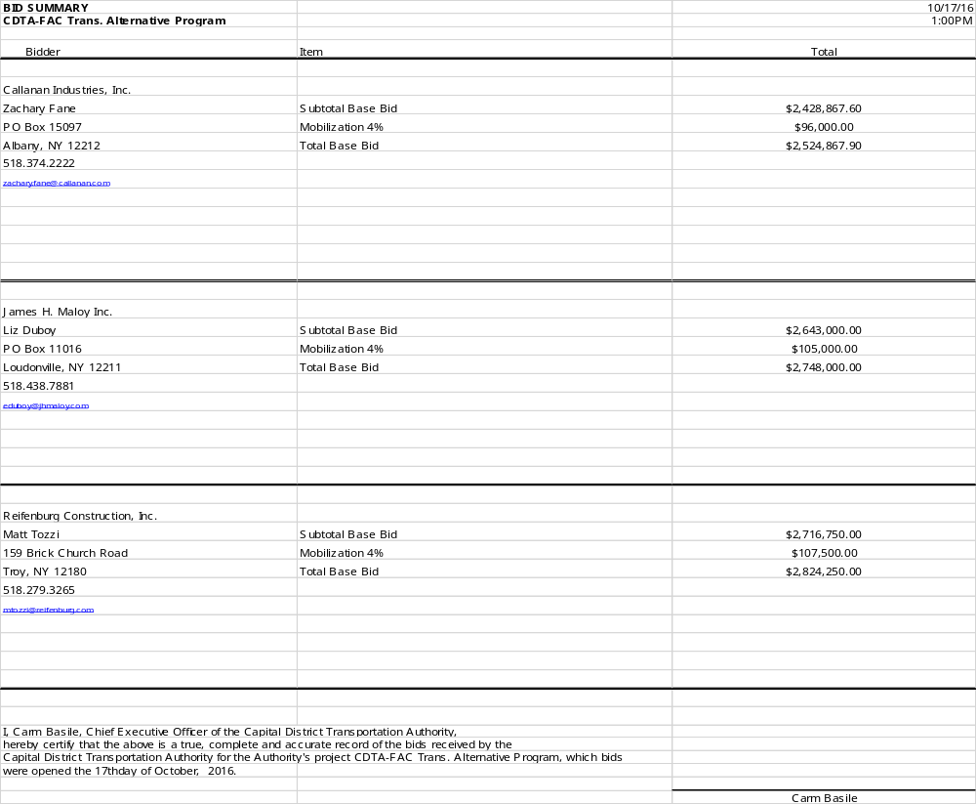
CAPITAL DISTRICT TRANSPORTATION AUTHORITY
Staff Contract Award Certification
1. TYPE OF CONTRACT (check one):
__X Construction & Maintenance _ ___ Goods, Commodities & Supplies ____ Bus Purchase
____ Services & Consultants __ __ Transportation & Operational Services

2. TERMS OF PERFORMANCE (check one):
_ X_ One-Shot Deal: Complete scope and fixed value
____ Fixed Fee For Services: Time and materials - open value
__ _ Exclusive Purchase Contract: Fixed cost for defined commodity with indefinite quantity
____ Open Purchase Contract: Commitment on specifications and price but no obligation to buy
____ Change Order: Add on to existing contract

3. CONTRACT VALUE:
_$2,777,355 (NTE)_______________ fixed estimated (circle one)

4. PROCUREMENT METHOD (check one):
_ ___ Request for Proposals (RFP) _X_ __ Invitation for Bids (IFB) ____ Other

5. TYPE OF PROCEDURE USED (check one):
____ Micro Purchases (Purchases up to $2,499.00) ____ Small Purchases ($25,000 up to $$100,000)
_X_ _ Sealed Bid/Invitation for Bids (IFB) (Over $100,000) __ __ Request for Proposals (RFP)
____ Professional Services (Over $25,000) ____ Sole or Single Source (Non-Competitive)

6. SELECTION CRITERION USED:
Number of Proposals/Bids Solicited #_14____ or Advertised
Number of Proposals/Bids Received #_3_____

Attach Summary of Bids/Proposals

- Disadvantaged/Minority Women’s Business Enterprise (D/MWBE) involvement
Are there known D/MWBEs that provide this good or service? Yes No
Number of D/MWBEs bidding/proposing ____0______
D/MWBE Certification on file? Yes No Not Applicable
Was contract awarded to a D/MWBE? Yes No
Number of D/MWBE Subcontractors EMI Guiderails (WBE & DBE), Stilsing Electric (WBE & DBE

8. LEGAL NAME and ADDRESS OF CONTRACTOR/VENDOR: Callanan Industries, Inc.______________________
PO Box 15097________________________________
Albany, NY 12212___________________ _________
9. SOURCE OF FUNDS: _2015 Transportation Alternatives Program Grant-$2,050,000, FY18 BRT set-aside of the regional Transportation Improvement Program-$727,355__________________________________________________________________

10. COMPLIANCE WITH STATE AND FEDERAL RULES:
Non-Collusion Affidavit of Bidder (Yes, No, N/A)
Disclosure & Certificate of Prior Non-Responsibility Determinations (Yes, No, N/A)
Disclosure of Contacts (only RFPs) (Yes, No, N/A)
Certification with FTA’s Bus Testing Requirements (Yes, No, N/A)

11. RESPONSIBLE STAFF CERTIFIES THE INTEGRITY OF THIS PROCUREMENT/CONTRACT:

__Stacy Sansky, Director of Procurement_____ DATED: _November 21, 2016_ _ _________
Capital District Transportation Authority
Agenda Action Proposal

Subject: Contract award for bus batteries to The Battery Store of Schenectady, New York.

Committee: Performance Oversight
Committee Meeting Date: December 7, 2016
Board Action Date: December 14, 2016

Background:
Batteries are procured on a regular basis to ensure price and availability. The current contracts for bus batteries is expiring.

Purpose:
CDTA utilizes 2 different batteries in our vehicles. Batteries are part of ongoing maintenance and upkeep and are replaced as required.

Summary of Proposal:
An Invitation for Bids (IFB) was issued for bus batteries. The IFB indicated performance requirements for each battery type as well as estimated quantities based on usage history. Sixteen (16) vendors downloaded the IFB and five (5) bids were received. Two different vendors provided the lowest responsive and responsible bids for the two different batteries. These two firms currently provide batteries to CDTA.

One vendor does not require Board action to issue a contract because the dollar value falls below approval thresholds. The other vendor, The Battery Store requires approval because the contract value is greater than $100,000.

Staff recommends a contract to purchase bus batteries from The Battery Store of Schenectady, New York (A WBE firm) for an estimated $117,483 over two years. Upon approval, a contract will be executed for a term of two years.

Financial Summary and Source of Funds:
The total contract value is estimated at $117,483 with funds coming from FY17 & FY18 Operating Budgets. This cost is the same as the previous contract for the same battery. Actual costs will be determined by usage. The anticipated cost breakdown is below:
Year 1: $53,074
Year 2: $64,409

Prepared by:
Stacy Sansky, Director of Procurement

Project Manager:
Lance Zarcone, Director of Maintenance

Memorandum

Date: November 17, 2016

To: Members, Performance Oversight Committee

From: Lance Zarcone, Director of Maintenance

Subject: Bus Battery Purchase

Overview
CDTA recently solicited an Invitation for Bid (IFB) asking a firm to supply bus batteries. An automotive battery is an energy source that supplies electric. Typically, batteries are used to start a vehicle. CDTA vehicles require two group type of batteries, 8D and 31. The numbers define the physical size of the battery case. CDTA uses these two types of batteries in our fixed route and STAR fleet.
Bids were solicited and five bids were received. The lowest qualified bidder for the group 31 battery is The Battery Store of Schenectady, New York (A WBE firm). CDTA is currently doing business with both firms and is satisfied with their product and service.

At this time staff recommends award to The Battery Store of Schenectady, New York.
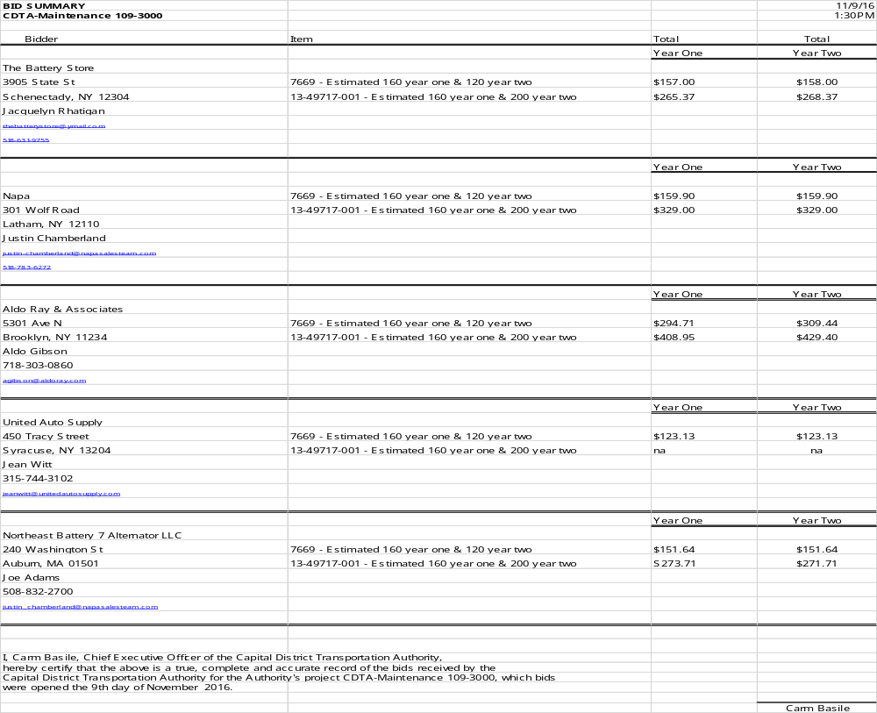
CAPITAL DISTRICT TRANSPORTATION AUTHORITY
Staff Contract Award Certification
1. TYPE OF CONTRACT (check one):
__ _ Construction & Maintenance _ X___ Goods, Commodities & Supplies ____ Bus Purchase
____ Services & Consultants __ __ Transportation & Operational Services

2. TERMS OF PERFORMANCE (check one):
_ _ _ One-Shot Deal: Complete scope and fixed value
____ Fixed Fee For Services: Time and materials - open value
_X _ Exclusive Purchase Contract: Fixed cost for defined commodity with indefinite quantity
____ Open Purchase Contract: Commitment on specifications and price but no obligation to buy
____ Change Order: Add on to existing contract

3. CONTRACT VALUE:
_$117,483_________________________ fixed estimated (circle one)

4. PROCUREMENT METHOD (check one):
_ ___ Request for Proposals (RFP) __X __ Invitation for Bids (IFB) ____ Other

5. TYPE OF PROCEDURE USED (check one):
____ Micro Purchases (Purchases up to $2,499.00) ____ Small Purchases ($25,000 up to $$100,000)
_X _ Sealed Bid/Invitation for Bids (IFB) (Over $100,000) __ __ Request for Proposals (RFP)
____ Professional Services (Over $25,000) ____ Sole or Single Source (Non-Competitive)

6. SELECTION CRITERION USED:
Number of Proposals/Bids Solicited #__16___ or Advertised
Number of Proposals/Bids Received #__5_____

Attach Summary of Bids/Proposals

- Disadvantaged/Minority/Women’s Business Enterprise (D/MWBE) involvement
Are there known D/MWBEs that provide this good or service? Yes No
Number of D/MWBEs bidding/proposing _1_________
D/MWBE Certification on file? Yes No Not Applicable
Was contract awarded to a D/MWBE? Yes No (WBE)
Number of D/MWBE Subcontractors _0_________

8. LEGAL NAME and ADDRESS OF CONTRACTOR/VENDOR: The Battery Store, LLC______________________
3905 State Street_____________________________
Schenectady, NY 12304______________ _________
9. SOURCE OF FUNDS: ____FY17&18 Operating Budget___________________________________________________

10. COMPLIANCE WITH STATE AND FEDERAL RULES:
Non-Collusion Affidavit of Bidder (Yes, No, N/A)
Disclosure & Certificate of Prior Non-Responsibility Determinations (Yes, No, N/A)
Disclosure of Contacts (only RFPs) (Yes, No, N/A)
Certification with FTA’s Bus Testing Requirements (Yes, No, N/A)

11. RESPONSIBLE STAFF CERTIFIES THE INTEGRITY OF THIS PROCUREMENT/CONTRACT:

__Stacy Sansky, Director of Procurement_____ DATED: __November 14, 2016 _ _________
Capital District Transportation Authority
Agenda Action Proposal

Subject: Contract award for bike share pilot program to Social Bicycles of Brooklyn, New York.

Committee: Performance Oversight
Committee Meeting Date: December 7, 2016
Board Action Date: December 14, 2016

Background:
Through CDTA’s partnership with the Capital Region Bike Share Task Force the desire for a regional bike share program was identified.

Purpose:
Provision of bicycle rental options in the Cities of Albany, Saratoga Springs, Schenectady and Troy that complement CDTA’s service and integrate with CDTA’s Navigator program.

Summary of Proposal:
A Request for Proposal (RFP) was issued for a flexible and automated on-demand (self-service) bicycle sharing system. The system will allow the general public to rent bicycles at low cost within a network of stations and return them to any station within the system. Six (6) firms downloaded the RFP and three (3) submitted proposals. Two of these firms were invited to participate in interviews with a review team comprised of Marketing, Finance and Planning Department Staff.

After consideration of the proposals, interview conversations and reference projects staff recommends a two-year contract a Bike Share Pilot program be awarded to Social Bicycles of Brooklyn, New York for an estimated initial investment of $900,000. This amount includes bike purchases, infrastructure and operating expenses. Upon Board approval, a contract will be executed immediately with an initial order of 160 bikes for a summer 2017 program start. (An additional 140 bikes can be ordered in year 2 of the contract.)

Financial Summary and Source of Funds:
Travel Demand Management: $200,000
Corporate Sponsorships: $300,000
FY2018 Capital Plan: $400,000

Total: $900,000

Prepared by:
Stacy Sansky, Director of Procurement

Project Manager:
Jonathan Scherzer, Director of Marketing


Memorandum

December 2, 2016

To: Chief Executive Officer

From: Director of Marketing

Subject: Award for Bike Share

Background
We are developing a regional bike share program as part of our work to provide people who live and work here with a broad menu of mobility options. This project is born out of our work with the Capital Region Bike Share Task Force, which identified the elements needed to institute a regional bike sharing program. Such a system will allow people to rent bicycles within a network of self-serve stations, including use of existing regional infrastructure. It will be integrated with our Navigator pay system making smart card and mobile payments attractive to a wider audience. We want to launch the program in summer 2017, gradually introducing bikes, stations and payment kiosks over an 18-month period. This requires award to a contractor who will provide equipment for the program along with maintenance and operations support.

Project Outline

The operation of a bike share program includes a partner who provides equipment and support to manage it. In our work, we identified the need for a scalable system with about 300 vehicles and portable stations. Bicycles need to be theft-resistant with proprietary construction and locking systems. We will develop an easy to use website and mobile application so customers can register and check bicycle availability. The program will offer pricing for membership and one-time use. The system will be flexible so bicycles can be used near their stations for pop-up events and for ease of return. There are several vendors that provide infrastructure for this system and our requirements are familiar to most, if not all of them.

We will create custom branding opportunities (on bicycle frames, on the website, on the mobile app, on stations). Marketing will promote environmental and health benefits for customers and employers. We see this convergence offering a viable project that will add to our mobility menu with the potential to generate membership and corporate support.

We issued a Request for Proposals (RFP) for a vendor to provide bicycles, stations and infrastructure. The selected company will also provide operations and maintenance assistance. We received three proposals and a review team looked at them in detail. Based on our scoring systems, two firms were invited for interviews (BCycle and Social Bicycles). The companies are similar in experience, installations and pricing. A key for us is the ease of technical integration with CDTA’s Navigator as a form of payment.

Staff selected Social Bicycles based in Brooklyn, New York. Social has more than 5,000 bikes in 30 locations across the globe and provides a variety of services. We agreed on a program that will have Social supporting rollout of a fully integrated system, using Navigator as a payment option. Their proposal provides a lower cost per bike and capability to provide an already-in-use smart bicycle. Those items along with fewer station infrastructure requirements, a simple pricing structure and a customizable digital customer interface placed them ahead of their competitor.

We plan to phase-in bicycles and infrastructure over a two-year period. If all goes as planned, we will begin the pilot in late summer 2017 with about 160 bikes. We will break for the winter and let the program run again in spring 2018 before considering expansion. Our contract with Social Bicycles will be a “not to exceed” 300 bicycles on full build out. The agreement will cover the purchase of bicycles, associated infrastructure and operating agreements.

Program Cost and Revenue Expectations
Startup and first year cost is expected to be about $900,000. This includes all equipment, bicycles and system integration. It also includes program planning, site selection, along with ongoing operations and maintenance support. Our employees will not be involved in the operation or maintenance of this equipment. We will be involved in product development, marketing, advertising and pricing. Growth is dependent on the revenue we generate from customers, revenue we raise from sponsorships, and our success on grant submissions.

Funding for this program will come from a variety of sources, including Travel Demand Management, corporate underwriting and our FY2018 capital plan. We have also applied for Congestion Mitigation and Air Quality grant funding. This would provide $2 million over the next five years. We are confident that all or most of this funding will be approved and it will cover operation and capital needs. Our application is supported by letters from the cities of Albany, Saratoga Springs, Schenectady and Troy, all of which agreed to provide a portion of the local match funds.

Recommendation
Staff recommends award of a contract to Social Bicycles of Brooklyn, New York for a two-year period. We will begin the pilot in summer 2017 with 160 bikes, with potential for a full complement of 300 bikes by year two. The agreement will cover the purchase of bicycles, infrastructure and maintenance. The program buildup in 2017 will cost $900,000 including the purchase of bicycles, infrastructure and support for ongoing operations.

Copy: Vice President Finance and Administration
Director of Finance
Director of Procurement
Mobility Manager

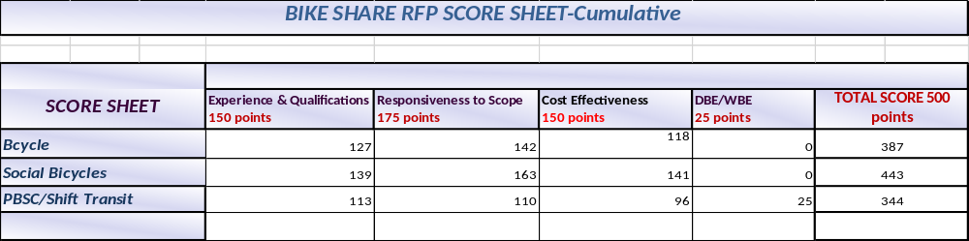

CAPITAL DISTRICT TRANSPORTATION AUTHORITY
Staff Contract Award Certification
1. TYPE OF CONTRACT (check one):
__ _ Construction & Maintenance _ ___ Goods, Commodities & Supplies ____ Bus Purchase
__X_ Services & Consultants __ __ Transportation & Operational Services

2. TERMS OF PERFORMANCE (check one):
_ _ _ One-Shot Deal: Complete scope and fixed value
____ Fixed Fee For Services: Time and materials - open value
__ _ Exclusive Purchase Contract: Fixed cost for defined commodity with indefinite quantity
__X_ Open Purchase Contract: Commitment on specifications and price but no obligation to buy
____ Change Order: Add on to existing contract

3. CONTRACT VALUE:
_$900,000_________________________ fixed estimated (circle one)

4. PROCUREMENT METHOD (check one):
_ X___ Request for Proposals (RFP) __ __ Invitation for Bids (IFB) ____ Other

5. TYPE OF PROCEDURE USED (check one):
____ Micro Purchases (Purchases up to $2,499.00) ____ Small Purchases ($25,000 up to $$100,000)
__ _ Sealed Bid/Invitation for Bids (IFB) (Over $100,000) _X_ __ Request for Proposals (RFP)
____ Professional Services (Over $25,000) ____ Sole or Single Source (Non-Competitive)

6. SELECTION CRITERION USED:
Number of Proposals/Bids Solicited #__6___ or Advertised
Number of Proposals/Bids Received #__3_____

Attach Summary of Bids/Proposals
- Disadvantaged/Minority Women’s Business Enterprise (D/MWBE) involvement
Are there known D/MWBEs that provide this good or service? Yes No
Number of D/MWBEs bidding/proposing ___0______
D/MWBE Certification on file? Yes No Not Applicable
Was contract awarded to a D/MWBE? Yes No
Number of D/MWBE Subcontractors ___0_______

8. LEGAL NAME and ADDRESS OF CONTRACTOR/VENDOR: Social Bicycles, Inc.__________________________
55 Prospect Street___________________________
_Brooklyn, NY 11201_________________ _________

9. SOURCE OF FUNDS: _TDM-$200,000, Corporate Sponsorship-$300,000, FY18 Capital Plan- $400,000____________

10. COMPLIANCE WITH STATE AND FEDERAL RULES:
Non-Collusion Affidavit of Bidder (Yes, No, N/A)
Disclosure & Certificate of Prior Non-Responsibility Determinations (Yes, No, N/A)
Disclosure of Contacts (only RFPs) (Yes, No, N/A)
Certification with FTA’s Bus Testing Requirements (Yes, No, N/A)

11. RESPONSIBLE STAFF CERTIFIES THE INTEGRITY OF THIS PROCUREMENT/CONTRACT:

__Stacy Sansky, Director of Procurement_____ DATED: __ _November 29, 2016 _________

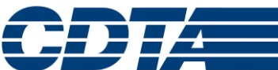

Memorandum

November 28, 2016

To: Members, Performance Oversight Committee

From: Director of Maintenance

Subject: Fleet Inspection Audit Results

Background
We recently conducted our annual inspection audit of the fleet, facilities, along with compliance to safety regulations and required record keeping. We have been doing this since November 2003 with our partners from the Transit Resource Center. TRC works with us to improve the audit process, reporting, and the expectations for our employees. They inspect 30% of our fleet, randomly selecting buses to insure all vehicle types are represented from our operating divisions. Bus inspections are completed in accordance with State and Federal standards, recording all defects. A small number of vehicles are also selected for records review.

As we have shown in the past, we are one of the only maintenance shops in the country that engages in this type of self-assessment. This grew out of a crisis situation and is now a staple of our department’s improvement program.

Reporting Period
Their report covers findings from the audit conducted from October 3 through October 14, 2016.

Methodology
TRC auditors use an industry accepted process to sample and inspect buses. They categorize defects as A-type or B-type. This designation denotes the severity of each vehicle defect identified.

- A Defect – The more critical category agreed on by TRC and CDTA. An “A” defect requires immediate attention and repair. It would keep a bus from returning to service if not corrected. “A” defects include inadequate brakes and tire tread, non-functioning turn signals, and major oil or fuel leaks.

- B Defect – This category indicates defects that require attention at or before the next scheduled service inspection. “B” defects include loose grab rails, exterior damage, leaky windows and minor oil leaks.

Summary of Findings
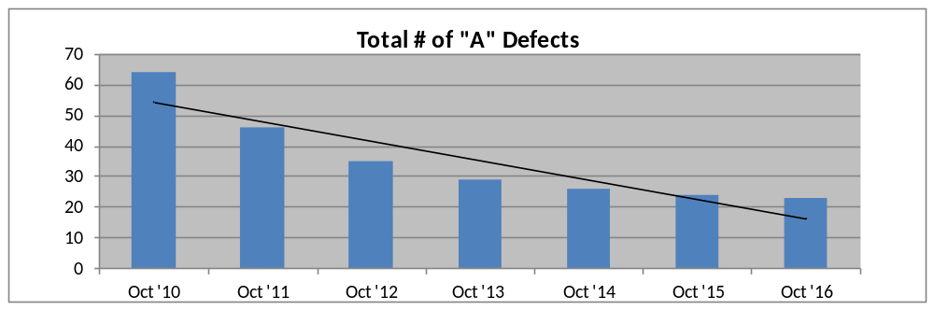A total of 70 buses were inspected. Our “A” defects decreased from 24 to 23 continuing an eight-year downward trend organization-wide. The Schenectady Division showed a reduction in “A” defects, while Albany and Troy saw a slight increase in their numbers.

Total defects were up this year from 268 to 286, with an average of 4.1 defects per bus, compared to 3.8 defects per bus last year. The categories that make up most “B” defects are interior, exterior and engine compartment. Engine compartment and exterior defects have increased slightly, while interior defects saw a decrease of 65%. Even though mostly cosmetic in nature, NOVA buses continues to have the largest number of defects per bus model due to their age.
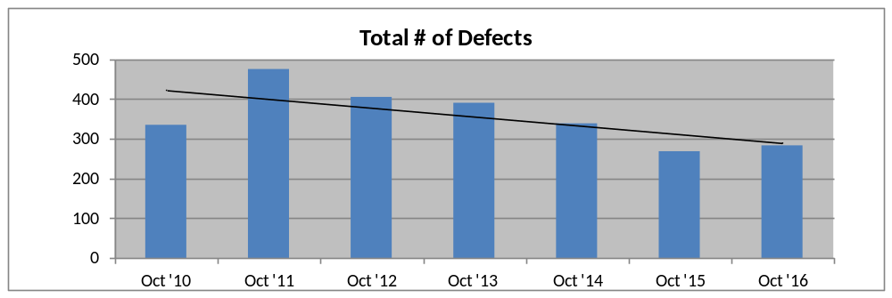

TRC staff also reviews our Preventive Maintenance Inspection (PMI) program for on time performance. All of the 15 buses examined were inspected on time, giving us a perfect score of 100% for the sixth consecutive audit.

The audit includes garage inspections, noting improvements and deficiencies. Albany, Troy and Schenectady facilities continue to be in good condition with bright lighting, minimal clutter and a clean work environment. Noted improvements include new bathroom and locker room facilities in Albany, and new wheel alignment equipment. Tool vending machines were added in Albany to organize and track specialty tools for technicians. There were no major issues that required immediate follow-up.

Conclusions and Action Steps
The 2016 audit produced similar results as our 2015 audit. A respectable defect average continued and many improvements to our facilities were made. Going forward, we will take the following actions:

- Continue Quality Assurance inspections performed by Trainers
- A more comprehensive look at Scheduled vs. Unscheduled repairs
- Focus on defects and repairs driven from Preventative Maintenance Inspections
- Additional dedicated staff to work on improving the body condition of the fleet

Our Maintenance employees are very dedicated and they seek continued excellence. Please feel free to contact me if you have any additional questions.
Copy: Chief Executive Officer

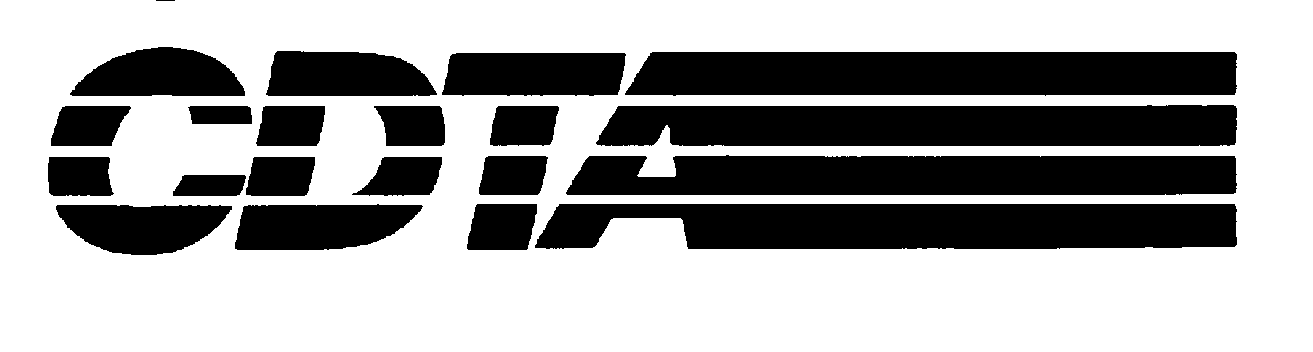

Memo

Date: November 15, 2016

To: Chairman, Performance Oversight Committee

From: General Counsel

cc: Chairman, Board of Directors
Vice President of Finance and Administration
Chief Executive Officer

Subject: Risk Management and Workers Compensation Self-Insurance Accounts, as of 9/30/16

Our procedures require a quarterly review of the adequacy of the Risk Management Self-Insurance Account and the separate Workers Compensation Self-Insurance Account.
1. Risk Management:

CDTA is self-insured for most liability exposures up to $2 million. If at all possible, liability and automobile (AL and PD) claims are managed and defended internally. These claims include bodily injury, property damage, and certain other claims including no-fault.

Reasonable prudence dictates that in view of the $2 million self-insured retention and the volatility of the market, we should be prepared to absorb at least one total loss (preferably two) along with the projected value of incurred losses.

- Projected Losses (incurred but unpaid): $973,650
(decrease of $19,364 (-2%) for the quarter)
- Self-Insured Retention (one) $2,000,000
- Market Value of Account: $3,937,860
(decrease of $4,575 (-.12%) for the quarter)
We are currently able to cover one total loss plus the projected value of our incurred losses.
2. Workers Compensation:

We have retained an actuary to project monthly expenditures under the self-insurance program for workers’ compensation that was initiated on 8/14/02. This formula is based upon actual experience, an annual valuation at the end of the fiscal year, and an annual projection of expenses adjusted for actual expenses in the current year. The projection includes both IBNR and the projected value of claims, expenses and assessment.
- Projected Claims: $7,652,220
(decrease of $165,288 (-2.1%) for the quarter)
• Market Value of Account: $8,054,715
(decrease of $210,965 (-2.6%) for the quarter)

The ratio of predicted liabilities to account value continues to be approximately 1:1. We continue to be fully-funded in this program.

- Liability/Auto Claims:

As of 9/30/16, we had 39 pending liability claims, 28 of which were in suit. Seven of the pending cases are inactive and are in the process of being closed out. The majority of the active claims are in various stages of discovery, while a few have been referred to outside counsel and are scheduled for trial in the near future. As of 9/30/16, CDTA had 10 liability claims with reserves of $10,000 or more, including four liability claims with reserves of $25,000 or more. It is always our intention to carry adequate funds to cover the aggregate value of anticipated losses.

Conclusion: It is my opinion that the balances of the Risk Management and Workers’ Compensation Self-Insurance Accounts are adequate to meet the anticipated needs of CDTA and its subsidiaries at the present time. Due to the high-risk nature of our operations and our increasing ridership, we anticipate an increase in claims made against the Authority. Because of our self-insured status, it is prudent to maintain adequate funds to account for the increases in claims.

Please feel free to contact me if you have any questions.

AAA

The total no longer includes the $200,000 projected value from previous retrospective insurance plans; previous plans have now been closed out.

