CDTA COMMITTEE AGENDA

Performance Oversight Committee

June 22, 2016

Start Time: 12:00 pm; Anticipated End Time: 2:00 pm

110 Watervliet Avenue

Committee Item Responsibility
Call to Order Tom Owens

Ascertain Quorum Tom Owens

Agenda Approval Tom Owens

Approve Minutes of May 18, 2016 Tom Owens

Consent Agenda Items
- Approve Contract for Bus Purchases (10 minutes) Stacy Sansky
- Approve Purchase of Twelve 40-foot Buses (5 minutes) Stacy Sansky
- Approve Sole Source Purchase of Camera Equipment (5 minutes) Stacy Sansky
- Approve Sole Source Contract for Site Improvements at AMC (5 minutes) Stacy Sansky
- Approve Contract for Brake Drums (5 minutes) Stacy Sansky
- Approve Contract for Facility Advertising (10 minutes) Stacy Sansky
- Approve Contract for Workers’ Comp/TPA Services (10 minutes) Stacy Sansky
- Annual Review of Drug and Alcohol Policy (10 minutes) Tom McKie

Audit Committee
- Internal Audit Monthly Report (5 minutes) Sarah Matrose

Investment Committee
- Update on Committee Activities / Reports (5 minutes) Tom Owens

Administrative Discussion Items
- Accident Review Annual Report (20 minutes) Tom McKie
- Monthly Management Report (10 minutes) * Mike Collins
- Monthly Non-Financial Report (10 minutes) * Chris Desany

Executive Session
- Security Update Monthly Report (5 minutes) Rick Vines

For the Good of the Order

Next Meeting Date: July 20, 2016

Adjourn

* Indicates Material (Or Additional Material) Will Be Provided at Meeting



Capital District Transportation Authority
Performance Oversight Committee
Meeting Minutes – May 18, 2016 at 12:00 pm at 110 Watervliet Avenue

In Attendance
Tom Owens (Chair), Art Young, Joe Spairana, Corey Bixby, Carm Basile (CEO), Christopher Desany (CSL), Mike Collins, Fred Gilliam, Amanda Avery, Lance Zarcone, Stacy Sansky, Jaime Watson, Rick Vines, Phil Parella, Sarah Matrose, Ed Wolk, Dan Holdsworth, Patricia Cooper, Mark Wos, Margie Harvey, Thomas Guggisberg, Kathy Colbert

Meeting Purpose: Regular meeting of the Performance Oversight Committee

It was noted that a quorum was present. The minutes from the April 20, 2016 meeting were reviewed and approved.

Consent Agenda Items

Approve Purchase of Scheduling Software Module
In 2000, CDTA implemented our fixed route scheduling system (HASTUS) which was competitively procured and provided by GIRO. This procurement is for the purchase of an additional module, HASTUS-bid, to manage the employee pick process in an automated way.
Staff is satisfied with this vendor, and has verified that pricing is fair and reasonable.

The Committee recommends a sole source contract be awarded for scheduling software to GIRO Inc. of Montreal, Quebec in an amount of $119,300 plus $5,500 in annual maintenance fees.

Approve Purchase of Two Articulated Buses
In December of 2014, the Board passed a resolution a five-year contract for the purchase of articulated heavy-duty transit vehicles. Staff recommends purchasing vehicles from this contract to replace vehicles in the fleet that have reached the end of their useful life.

The Committee recommends that a notice to proceed be awarded to New Flyer of America, Inc. for the purchase of two articulated buses for an amount not to exceed $1,593,298.

Acceptance of 10% State Share of Two Federal Grants
New York State provides a 10% match to the Authority’s federal funds. The State requires a Board resolution to access these funds and it will allow the organization to accept the State portion of formula allocation funds This year federal and state funds are being utilized to purchase 12 40-foot vehicles and perform the engineering and design of the new BRT lines.

The Committee recommends that these funds be accepted in a total amount of $278,646.

Audit Committee Items

Approve FYE 2016 Audit Draft
Donna Gonser and Christa Linsey from Lumsden & McCormick, CDTA external auditors, presented the draft FY2016 year-end audit and provided CDTA with a clean opinion. Topics of the presentation included the process and various audit reports that were used, the change in accounting principle: GASB 68, observations and recommendations, and the balance sheet.

The Committee recommends approval of the FY2016 Financial and Compliance Report prepared by Lumsden & McCormick, LLP, dated March 31, 2016.

Monthly Audit Report
Sarah Matrose gave the monthly audit report. Works in progress included review of the RRS parking contract and the dependent benefits audit.

Investment Committee Items
Tom Owens discussed Investment Committee activities. The monthly investment report provided by Hugh Johnson Advisors was reviewed and accepted by the Committee.

Administrative Discussion Items

Workplace Safety Annual Report
Rick Vines gave the annual safety report. We have just completed the eighth full year of our comprehensive program to improve workplace safety, and a summary accident injury and workers compensation claim trends were presented. We started our Comprehensive Workplace Safety Program in January 2008 and for fiscal years 2009 through 2016 we averaged 76 injuries per year, including 19 severe cases. We have seen a significant decrease in both injuries and severe injury cases since program inception and we have continued this over time. In FY 2016 we achieved a significant milestone: the lowest number of total employee injuries ever reported (57).

Risk Management and Workers’ Compensation Quarterly Report
Our procedures require a quarterly review of the adequacy of the Risk Management Self-Insurance Account and the Workers Compensation Self-Insurance Account. The Committee has determined that our accounts are adequate at this time. Amanda Avery can provide details.

Monthly Management (financial) Report
Mike Collins gave the monthly management report. Mortgage tax receipts were under budget projections by 16.4%. Wages were also slightly under budget. Claim payments and liability claims were under budget this month as well. General insurance was under budget due to a refund on our auto physical damage policy. We are in a satisfactory cash flow position at this time.

Monthly Non-Financial (performance) Report
Chris Desany gave the monthly non-financial report. As discussed over prior meetings, we made a few adjustments to the report beginning this fiscal year which include two-year and six-month average lines, the addition of scheduled vs. unscheduled work, and an adjustment in how we present ridership. Overall, measurements this month were positive. Total ridership was down 2.6% for the month, primarily due to fewer weekdays this year as compared to the same month last year. Taking that into account, ridership was flat. There were zero PMI’s not on time, and missed trips were at 33 this month. MDBSI was at 25,289. Scheduled work was at 61%, and Mr. Owens requested that we look into measuring this by hours as opposed to number of work orders. Staff will look into it. There 15 preventable and 26 non-preventable accidents, and 91% of customer complaints were closed within 10 days.

For The Good of the Order
No items.

Executive Session
No items.

Report Respectfully Submitted By:

______________________________________________________________________________
Christopher Desany, Chief Staff Liaison and VP of Planning and Infrastructure

Capital District Transportation Authority
Agenda Action Proposal

Subject: Contract award to Gillig, LLC of Hayward, California for the purchase of 40 foot buses.

Committee: Performance Oversight
Committee Meeting Date: June 22, 2016
Board Action Date: June 29, 2016

Background:
The current contract for 40 foot buses has expired. To ensure availability of vehicles for fleet replacement a new contract is required.

Purpose:
To insure the effective operation of fixed route service.

Summary of Proposal:
A Request for Proposals (RFP) was issued for a 5-year contract to buy forty foot (40’) diesel buses. Our plan is to purchase between 12-20 buses per year based upon available funding. This is consistent with our fleet purchasing plan, which aims to balance fleet age and maintenance requirements, while providing predictable costs for purchases and annual maintenance expenses.

The RFP provided detailed specifications for vehicles and performance. Prices were requested for 40’ diesel vehicles along with optional prices for tooling, training and extended warranties.
Review criteria were specified in five areas, and proposals were reviewed against those criteria; this included technical, warranty, delivery schedules, past performance and price.

All three major 40’ bus manufacturers submitted proposals for this RFP. Based on the evaluation criteria listed in the RFP, a technical review of each submittal was undertake by a staff committee. The review included detailed inspection of demonstration buses by our maintenance staff and bus operators. Price proposals were opened separately, after all of the technical reviews and inspection of demonstration buses was completed.

All three proposals were extremely competitive in price and technical scores and were asked to provide Best and Final Offers (BAFO). As a result of the BAFO process two manufacturers were still extremely competitive, Gillig, the incumbent manufacturer was decided to have the best overall offerings for our current needs. Gillig has provided 40’ buses to CDTA for the last 10 years and staff is satisfied with vehicle performance and after-market sales and support. A detailed summary of the procurement process is attached for review.

At this time staff is recommending award of a five-year contract for the purchase of 40’ buses be awarded to Gillig, LLC of Hayward, CA for the purchase of up to 125 vehicles over the contract term. All purchases from this contract will be presented to the Board for approval.

Upon Board approval a contract will be executed immediately.

Financial Summary and Source of Funds:
The base bus price is $449,610, plus selected options. Future year purchases will be tied to the Producer’s Price Index (PPI).

Prepared by:
Stacy Sansky, Director of Procurement

Project Manager:
Lance Zarcone, Director of Maintenance

Memorandum

June 7, 2016

To: Members, Performance Oversight Committee

From: Lance Zarcone

CC: Carm Basile, Chief Executive Officer

Re: Contract Award-40’ Bus Procurement

A new contract is required to continue with the replacement schedule for the fixed route bus fleet. An RFP was issued that specified the minimum performance requirements and estimated quantity of vehicles desired for the term of five years.

The entire evaluation process is outlined in the attached action item of procurement summary.

I fully support the contract award to Gillig for the purchase of 40’ buses. Over 50% of the CDTA fixed route fleet are now Gillig vehicles. These buses are well made, and both operators and mechanics rank them favorably for maintenance and drivability. Staff has developed positive relationship with Gillig sales and support over the past ten years. While some replacement tooling and training for new hires will be required with this new contract, overall additional costs will be minimal as CDTA already stocks Gillig parts and will only need to increase quantity of on-hand parts for certain items rather than entirely new parts.

I recommend that a five-year contract be awarded to Gillig for the purchase of 40’ buses.
Capital District Transportation Authority
Purchase of 40-foot Diesel Buses
Summary of Procurement Process

Overview:
The selection process utilized for selection of a bus manufacturer was a Request for Proposal (RFP). The RFP process not only allowed for staff to consider criteria of importance beyond price in making a decision, it allowed staff to negotiate with manufacturers. The negotiation process is critical to allow CDTA to ask for clarifications and request Best and Final Offers (BAFO).

The RFP was issued in accordance with federal, state and CDTA purchasing requirements. The RFP was publicly advertised and proposals were opened on April 18, 2016. For the first time staff utilized the APTA Bus Procurement Standard which is highly regarded as the best foundation of a bus specification available to transit systems. CDTA staff blended our specific needs into the APTA standard to create an RFP that outlined our technical and performance requirements along with our purchasing expectations (between 12-20 buses per year).

The RFP and Review Process:
The RFP sought proposals from qualified manufacturers that could meet specifications that were established. A total of three manufacturers (Gillig LLC, New Flyer of America and Nova Bus) submitted proposals. They were reviewed by a staff committee from Maintenance, Transportation, Inventory and Information Technology using the review criteria established in the RFP (see below).

All three manufacturers were required to provide a demonstration bus and to participate in an interview process with the review team. The demonstration bus was thoroughly inspected by maintenance technicians and trainers. The review team then took each bus on a test drive. During the test drive CDTA bus operators were allowed to drive the vehicle and evaluate the vehicle for ride smoothness and ease of use. At the end of the review process all three manufacturers were still considered to be competitive in their offerings. The review was based on the following criteria:
- Technical (50%)-Each manufacturer was rated and ranked in nearly 600 technical aspects of the buses being proposed. The specifications outlined baseline requirements for this criteria and manufacturers met, did not meet or exceeded the specification in each area. The technical points were categorized into one of four categories: Safety, Reliability, Maintenance and Operations. Additionally, rankings by Maintenance and Transportation employees based on their observations during the bus demonstration were included for a portion of the technical points.
- Price (30%)- The manufacturer’s price proposal was ranked with the lowest price best according to total acquisition cost, including base bus price, technical training, delivery and initially procured equipment. Price proposals were received in a separate sealed envelope and were not opened until all other rankings were completed to reduce price bias.
- Warranty (10%)-Baseline warranty requirements were established for individual components, and manufacturers were asked to provide CDTA with any additional costs that might be incurred.
- Delivery (5%)-A baseline delivery schedule of 36 calendar days was established. The best delivery received the highest ranking.
- Past Performance (5%)- Manufacturers supplied client references receiving higher credit for generally positive comments and less favorable comments receiving fewer points.

Since the initial manufacturer rankings were so competitive all three were invited to submit a Best and Final Offer. CDTA received two very competitive BAFO’s (essentially the same ranking), and further evaluated those proposals and discussed their merits. As a result of the entire evaluation process staff found that the proposal and BAFO submitted by Gillig most closely aligned with CDTA’s needs.

CAPITAL DISTRICT TRANSPORTATION AUTHORITY
Staff Contract Award Certification
1. TYPE OF CONTRACT (check one):
__ _ Construction & Maintenance _ X___ Goods, Commodities & Supplies ____ Bus Purchase
____ Services & Consultants __ __ Transportation & Operational Services

2. TERMS OF PERFORMANCE (check one):
_ _ _ One-Shot Deal: Complete scope and fixed value
____ Fixed Fee For Services: Time and materials - open value
__X _ Exclusive Purchase Contract: Fixed cost for defined commodity with indefinite quantity
____ Open Purchase Contract: Commitment on specifications and price but no obligation to buy
____ Change Order: Add on to existing contract

3. CONTRACT VALUE:
___$5,454,288 (Year 1, not to exceed)_______________________ fixed estimated (circle one)

4. PROCUREMENT METHOD (check one):
_ ___ Request for Proposals (RFP) __ __ Invitation for Bids (IFB) ____ Other

5. TYPE OF PROCEDURE USED (check one):
____ Micro Purchases (Purchases up to $2,499.00) ____ Small Purchases ($25,000 up to $$100,000)
__ _ Sealed Bid/Invitation for Bids (IFB) (Over $100,000) _X_ Request for Proposals (RFP)
____ Professional Services (Over $25,000) ____ Sole or Single Source (Non-Competitive)

6. SELECTION CRITERION USED:
Number of Proposals/Bids Solicited #_3____ or Advertised
Number of Proposals/Bids Received #_3______

Attach Summary of Bids/Proposals

- Disadvantaged Business Enterprise (DBE) involvement
Are there known DBEs that provide this good or service? Yes No
Number of DBEs bidding/proposing ____0______
DBE Certification on file? Yes No Not Applicable
Was contract awarded to a DBE? Yes No
Number of DBE Subcontractors _____0 (Bus Manufacturers must maintain an approved DBE Goal Plan on file with FTA to be eligible to participate in FTA funded vehicle procurements)_____

8. LEGAL NAME and ADDRESS OF CONTRACTOR/VENDOR: Gillig, LLC__________________________________
25800 Clawiter Road__________________________
Hayward, California 94545___________ _________
8. SOURCE OF FUNDS: _______FY17 Capital Plan__________________________________________________________

9. COMPLIANCE WITH STATE AND FEDERAL RULES:
Non-Collusion Affidavit of Bidder (Yes, No, N/A)
Disclosure & Certificate of Prior Non-Responsibility Determinations (Yes, No, N/A)
Disclosure of Contacts (only RFPs) (Yes, No, N/A)
Certification with FTA’s Bus Testing Requirements (Yes, No,)

10. RESPONSIBLE STAFF CERTIFIES THE INTEGRITY OF THIS PROCUREMENT/CONTRACT:

__Stacy Sansky, Director of Procurement_____ DATED: __ June 9, 2016_ _________
Capital District Transportation Authority
Agenda Action Proposal

Subject: Purchase of twelve 40 foot buses from Gillig, LLC of Hayward, California.

Committee: Performance Oversight
Committee Meeting Date: June 22, 2016
Board Action Date: June 29, 2016

Background:
The current fleet replacement plan calls for annual vehicle purchases and disposal of vehicles that have reached the end of their useful life.

Purpose:
To insure the effective operation of fixed route service.

Summary of Proposal:
A Request for Proposals (RFP) was issued for a 5-year contract to buy forty foot (40’) diesel buses and approved through earlier Board action. Staff is recommending the purchase of twelve (12) vehicles upon receipt of a fully executed contract. This is consistent with our fleet purchasing plan, which aims to balance fleet age and maintenance requirements, while providing predictable costs for purchases and annual maintenance expenses.

At this time staff is recommending the purchase of an order of twelve (12) buses from this contract for a cost of $459,411 per vehicle. This cost includes extended warranties for engine, HVAC and transmission. An additional $29,444 is required for training and tooling, as CDTA has a number of new maintenance staff who require training. These buses will replace an equal number of vehicles that have reached the end of their useful life, and were included in the previously approved FY17 budget. Anticipated delivery is early summer of 2017.

Financial Summary and Source of Funds:
The total FY17 cost will not exceed $5,454,288 and is broken down below. Future year purchases will be tied to the Producer’s Price Index (PPI). This order will be funded from the FY2017 capital plan.

Description | Unit Cost | Quantity | Extended Cost
Base Bus | $449, 610 | 12 | $5,395,320
Extended Warranties | $9,801 | 12 | $29,524
Tooling | $14,444 | 1 | $14,444
Training | $15,000 | 1 | $15,000
TOTAL Year 1: |  |  | $5,454,288

Prepared by:
Stacy Sansky, Director of Procurement

Project Manager:
Lance Zarcone, Director of Maintenance

Capital District Transportation Authority
Agenda Action Proposal

Subject: Sole source contract for upgrades to the fixed camera system to Integrated Video Solutions, LLC of Chester New Jersey.

Committee: Performance Oversight
Committee Meeting Date: June 22, 2016
Board Action Date: June 29, 2016

Background:
This project will upgrade eight (8) Digital Video Recorders (DVRs) that have reached the end of their useful life.

Purpose:
These DVRs are used to store video collected at CDTA facilities. All existing cameras will be migrated to use the new DVRs.

Summary of Proposal:
The fixed camera system was part of the overall camera project that was competitively procured and awarded to March Networks. Integrated Video Solutions is the preferred installer for March Networks and has performed previous upgrades to the CDTA camera system.

As a sole source procurement valued at over $25,000 Board of Directors approval is required. Staff has reviewed the prices from Integrated Video Solutions and finds them to be fair and reasonable based on previous costs for similar work.

Financial Summary and Source of Funds:
The cost to replace the eight DVRs is $41,740 and it will be funded through the FY2017 Capital Plan.

Prepared by:
Stacy Sansky, Director of Procurement

Project Manager:
Rich Fantozzi, Software Architect

Date: June 03, 2016
To: Stacy Sansky, Director of Procurement
From: Christopher Desany, Vice President of Planning and Infrastructure
Re: Sole Source Recommendation for Fixed Camera DVR Replacement

Background:
In 2010, CDTA implemented our mobile and fixed camera system which was competitively procured and provided by March Networks. CDTA has installed March Networks technology at all five CDTA locations and most of our buses. With this project we intend to upgrade eight 4000 series Digital Video Recorders (DVRs) which have reached their end of useful life. These particular DVRs are used for storing video collected at CDTA facilities. The units will be replaced, configured and all existing cameras will be migrated to use the new DVRs.

Since the original contract award, we have used Integrated Video Solutions, LLC to provide support services for the camera system.

Justification:
This recommendation to award a sole source contract to replace DVRs and migrate cameras is based on a number of important considerations. Most importantly, the video system is proprietary, which limits us from pursuing other means to cost effectively install and migrate the existing DVRs through another vendor. Additional reasons to support this sole source recommendation include:

- Integrated Video Solutions has personnel that were integrally involved in the setup and configuration of the system when it was first put in.
- Integrated Video Solutions is familiar with the many nuances of the system and its relationship to our requirements and therefore has full knowledge of CDTA needs.
- Utilizing this vendor will result in a zero net increase in vendors at CDTA.
- Utilizing this vendor will require no third-party integration or customization, which reduces the risk inherent in custom third-party vendor development.
- This work is of a security/safety and time sensitive nature. Without doing this upgrade, we risk fixed cameras failing since the associated DVRs are no longer supported.
- The proposal is fair and reasonable based upon previous proposals and work completed for CDTA. Per unit costs re the same.

Staff Recommendation

I am recommending that a sole source contract be awarded to Integrated Video Solutions, LLC for DVR replacement and migration services for a total value of $41,740.

CAPITAL DISTRICT TRANSPORTATION AUTHORITY
Staff Contract Award Certification
1. TYPE OF CONTRACT (check one):
__X _ Construction & Maintenance _ ___ Goods, Commodities & Supplies ____ Bus Purchase
____ Services & Consultants __ __ Transportation & Operational Services

2. TERMS OF PERFORMANCE (check one):
_ X _ One-Shot Deal: Complete scope and fixed value
____ Fixed Fee For Services: Time and materials - open value
__ _ Exclusive Purchase Contract: Fixed cost for defined commodity with indefinite quantity
____ Open Purchase Contract: Commitment on specifications and price but no obligation to buy
____ Change Order: Add on to existing contract

3. CONTRACT VALUE:
_$41,740_________________________ fixed estimated (circle one)

4. PROCUREMENT METHOD (check one):
_ ___ Request for Proposals (RFP) __ __ Invitation for Bids (IFB) ____ Other

5. TYPE OF PROCEDURE USED (check one):
____ Micro Purchases (Purchases up to $2,499.00) ____ Small Purchases ($25,000 up to $$100,000)
__ _ Sealed Bid/Invitation for Bids (IFB) (Over $100,000) __ __ Request for Proposals (RFP)
____ Professional Services (Over $25,000) __X__ Sole or Single Source (Non-Competitive)

6. SELECTION CRITERION USED:
Number of Proposals/Bids Solicited #__1___ or Advertised
Number of Proposals/Bids Received #__1_____

Attach Summary of Bids/Proposals
- Disadvantaged Business Enterprise (DBE) involvement
Are there known DBEs that provide this good or service? Yes No
Number of DBEs bidding/proposing ____0______
DBE Certification on file? Yes No Not Applicable
Was contract awarded to a DBE? Yes No
Number of DBE Subcontractors ____0______

8. LEGAL NAME and ADDRESS OF CONTRACTOR/VENDOR: Integrated Video Solutions, LLC_______________
_95W. Main Street Suite 18-A__________________
_Chester, NJ 07930__________________ _________
9. SOURCE OF FUNDS: __FY17 Capital Plan____________________________________________________________

10. COMPLIANCE WITH STATE AND FEDERAL RULES:
Non-Collusion Affidavit of Bidder (Yes, No, N/A)
Disclosure & Certificate of Prior Non-Responsibility Determinations (Yes, No, N/A)
Disclosure of Contacts (only RFPs) (Yes, No, N/A)
Certification with FTA’s Bus Testing Requirements (Yes, No, N/A)

11. RESPONSIBLE STAFF CERTIFIES THE INTEGRITY OF THIS PROCUREMENT/CONTRACT:

__Stacy Sansky, Director of Procurement_____ DATED: June 13, 2016 _
Capital District Transportation Authority
Agenda Action Proposal

Subject: Sole source contract award to Bob Talham, Inc. of Troy, New York for site improvement work at Albany Medical Center.

Committee: Performance Oversight
Committee Meeting Date: June 22, 2016
Board Action Date: June 29, 2016

Background:
A sole source contract is required to ensure work is completed according to schedule.

Purpose:
Albany Medical Center (AMC) and CDTA have partnered to include transit enhancements as part of the Park South Revitalization through the Universal Access agreement that was executed last year. The first phase of those enhancements is scheduled to begin August 28, 2016.

Summary of Proposal:
An Invitation for Bids (IFB) was issued for site work that includes relocation of bus stops, installation of new bus shelters and pads and other enhancements. Although eleven firms downloaded the IFB, only a single bid was received and it was 75% over the independent cost estimate. Staff polled the bid list to reasons for lack of bids. The responses ranged from having a full calendar of work to the small size of the project during prime construction season. Since the bid received was extremely high staff requested a quote from CDTA’s current shelter installer, Bob Talham, Inc. for this work. The quote received by Bob Talham was within the engineering cost estimates; and therefore considered fair and reasonable, and work could be completed by the August 28, 2016 deadline.

Staff recommends a sole source contract be awarded to Bob Talham, Inc. of Troy, New York for site improvements at Albany Medical Center.

Financial Summary and Source of Funds:
$68,752
$13,750 (20% contingency)
TOTAL: $82,502 (not to exceed amount)
This project will be funded through the FY2017 Capital Plan.

Prepared by:
Stacy Sansky, Director of Procurement

Project Manager:
Mark Wos, Director of Facilities

Date: June 07, 2016
To: Stacy Sansky, Director of Procurement
From: Christopher Desany, Vice President of Planning and Infrastructure
Re: Sole Source Recommendation for Albany Medical Center (AMC) Site Improvements

Background:
Albany Medical Center (AMC) has desired to include transit enhancements to support a new development which is intended to revitalize the Park South neighborhood on the blocks between New Scotland Avenue, Dana Avenue, Myrtle Avenue, Morris Street and Robin Street in the city of Albany. This development includes medical office space, retail, and residential facilities and has led AMC to further its efforts to improve infrastructure in the Park South neighborhood and mitigate traffic impacts in the area. In the fall of 2015, CDTA entered into a joint agreement with Albany Medical Center, Capitalize Albany, and Tri-City rentals to provide Universal Access (UA) service to employees, tenants, and affiliates. On September 23, 2015, that service began and has since produced ridership of over 18,000. As part of that agreement, CDTA has agreed to invest in service enhancements to the area based on increased ridership demand. The first phase of those enhancements are scheduled to begin on August 28, 2016.

In May of 2016, CDTA issued an invitation for bids for qualified contractors to perform the site work required for the service enhancements in the area. The overall scope included relocation of bus stops, installation of new bus shelters and pads, a curb extension, and a mid-block pedestrian crossing.

The solicitation produced one bid from Callanan Industries, Inc. which was 75% over budget. Staff reached out to contractors to determine why the lack of response, and issues with the size and scope of project were cited as reasons. Staff has since reached out to our existing shelter installer, Bob Talham, Inc. for a quote for the same services and they responded with pricing that matches our engineering estimates.

CDTA has committed to AMC to have this work completed by mid-August, and placing a new bid package out for solicitation will not meet that goal. Additionally, waiting until the June Board meeting will also delay the project. As such, the Board was notified of the extenuating circumstances and Talham was given authorization to begin preliminary work at the site. We are seeking Board approval of this contract at the June meeting.

Justification:
This recommendation is to award a sole source contract to Bob Talham, Inc., Inc. for site improvements at the Albany Medical Center location. Reasons to support this sole source recommendation include:

- CDTA has worked with Talham for 10 years and work has been satisfactory.
- Talham is very qualified and can complete the work in the time frame required.

Recommendation
I am recommending that a sole source contract be awarded to Bob Talham, Inc. for site improvement services in an amount not to exceed $68,752 + $13,750 for contingency, for a total amount of $82,502.
CAPITAL DISTRICT TRANSPORTATION AUTHORITY
Staff Contract Award Certification
1. TYPE OF CONTRACT (check one):
__X _ Construction & Maintenance _ ___ Goods, Commodities & Supplies ____ Bus Purchase
____ Services & Consultants __ __ Transportation & Operational Services

2. TERMS OF PERFORMANCE (check one):
_ _ _ One-Shot Deal: Complete scope and fixed value
__X_ Fixed Fee For Services: Time and materials - open value
__ _ Exclusive Purchase Contract: Fixed cost for defined commodity with indefinite quantity
____ Open Purchase Contract: Commitment on specifications and price but no obligation to buy
____ Change Order: Add on to existing contract

3. CONTRACT VALUE:
_$82,502 (NTE)_________________________ fixed estimated (circle one)

4. PROCUREMENT METHOD (check one):
_ ___ Request for Proposals (RFP) __ X__ Invitation for Bids (IFB) ____ Other

5. TYPE OF PROCEDURE USED (check one):
____ Micro Purchases (Purchases up to $2,499.00) ____ Small Purchases ($25,000 up to $100,000)
__ _ Sealed Bid/Invitation for Bids (IFB) (Over $100,000) __ __ Request for Proposals (RFP)
____ Professional Services (Over $25,000) __X__ Sole or Single Source (Non-Competitive)

6. SELECTION CRITERION USED:
Number of Proposals/Bids Solicited #__11___ or Advertised
Number of Proposals/Bids Received #___1____

Attach Summary of Bids/Proposals
- Disadvantaged/Minority Women’s Business Enterprise (D/MWBE) involvement
Are there known D/MWBEs that provide this good or service? Yes No
Number of D/MWBEs bidding/proposing ____0______
D/MWBE Certification on file? Yes No Not Applicable
Was contract awarded to a D/MWBE? Yes No
Number of D/MWBE Subcontractors _____0_____

8. LEGAL NAME and ADDRESS OF CONTRACTOR/VENDOR: Bob Talham, Inc._
71 Brunswick Road_
Troy, NY 12180__________
9. SOURCE OF FUNDS: ______FY17 Capital Plan_____________________________________________

10. COMPLIANCE WITH STATE AND FEDERAL RULES:
Non-Collusion Affidavit of Bidder (Yes, No, N/A)
Disclosure & Certificate of Prior Non-Responsibility Determinations (Yes, No, N/A)
Disclosure of Contacts (only RFPs) (Yes, No, N/A)
Certification with FTA’s Bus Testing Requirements (Yes, No,N/A)

11. RESPONSIBLE STAFF CERTIFIES THE INTEGRITY OF THIS PROCUREMENT/CONTRACT:

__Stacy Sansky, Director of Procurement_____ DATED: ___June 13, 2016_________
Capital District Transportation Authority
Agenda Action Proposal

Subject: Contract award for Brake Drums to Vehicle Maintenance Program of Boca Raton, Florida.

Committee: Performance Oversight
Committee Meeting Date: June 22, 2016
Board Action Date: June 29, 2016

Background:
Brake drums are an essential bus part used on a regular basis that has a high associated cost. These parts are needed to ensure availability for brake repairs. Brake drums are competitively procured at regular intervals.

Purpose:
Brake drums are a critical part used to maintain a healthy bus fleet to ensure safe and reliable service.

Summary of Proposal:
An Invitation for Bids (IFB) was issued for brake drums. The IFB indicated performance requirements and estimated quantities based on usage history. Sixteen (16) vendors downloaded the IFB and eleven (11) bids were received. The bid received from Vehicle Maintenance Program was the lowest responsive and responsible bid. CDTA currently purchases other parts from Vehicle Maintenance Program and has found performance satisfactory.

Staff recommends a contract to purchase brake drums be awarded to Vehicle Maintenance Program of Boca Raton, Florida for an estimated $108,650. Upon approval a contract will be executed for a term of two years commencing August 15, 2016.

Financial Summary and Source of Funds:
The total contract value is estimated at $115,218 with funds coming from FY17 & FY18 Operating Budgets. This represents a 50% decrease in cost for brake drums. Actual costs will be determined by specific vehicle needs beyond forecasted preventative maintenance. An annual cost breakdown is below:

Year 1- $53,014
Year 2- $55,636

Prepared by:
Stacy Sansky, Director of Procurement

Project Manager:
Stacy Sansky, Director of Procurement
Paul Klippel, Inventory Manager

Memorandum

June 15, 2016

To: Mike Collins, Vice President of Finance and Administration

From: Stacy Sansky, Director of Procurement

CC: Procurement File

Re: CDTA Maint 101-3000 Brake Drums-Award Recommendation

Brake Drums are an essential part used in the maintenance of the CDTA fleet and a consistent and available supply is a requirement for our maintenance operations. The current contract will expire in August and a new one was required to ensure future price stability and parts availability.
Eleven bids were received, all from current suppliers of parts to CDTA. Vehicle Maintenance Program (VMP) provided the lowest overall bid and based on past performance are deemed to be responsible and able to provide brake drums per their price quote.
This price represents a 50% cost decrease from the cost of brake drums from the previous contract. The decrease in cost is attributed in part to lower usage of brake drums as new vehicles now come with disc brakes and do not require drums.
I recommend that this contract be moved to the Board of Directors for approval.
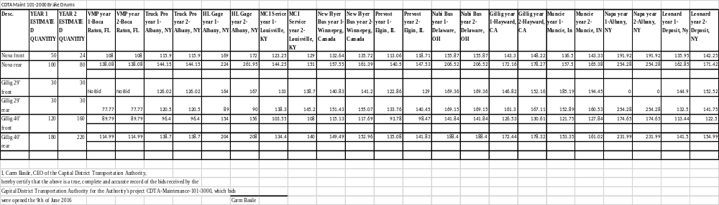
CAPITAL DISTRICT TRANSPORTATION AUTHORITY
Staff Contract Award Certification
1. TYPE OF CONTRACT (check one):
__ _ Construction & Maintenance _ X___ Goods, Commodities & Supplies ____ Bus Purchase
____ Services & Consultants __ __ Transportation & Operational Services

2. TERMS OF PERFORMANCE (check one):
_ _ _ One-Shot Deal: Complete scope and fixed value
____ Fixed Fee For Services: Time and materials - open value
__ X_ Exclusive Purchase Contract: Fixed cost for defined commodity with indefinite quantity
____ Open Purchase Contract: Commitment on specifications and price but no obligation to buy
____ Change Order: Add on to existing contract

3. CONTRACT VALUE:
$115,218__________________________ fixed estimated (circle one)

4. PROCUREMENT METHOD (check one):
_ ___ Request for Proposals (RFP) _X_ __ Invitation for Bids (IFB) ____ Other

5. TYPE OF PROCEDURE USED (check one):
____ Micro Purchases (Purchases up to $2,499.00) ____ Small Purchases ($25,000 up to $$100,000)
_X_ _ Sealed Bid/Invitation for Bids (IFB) (Over $100,000) __ __ Request for Proposals (RFP)
____ Professional Services (Over $25,000) ____ Sole or Single Source (Non-Competitive)

6. SELECTION CRITERION USED:
Number of Proposals/Bids Solicited #_16____ or Advertised
Number of Proposals/Bids Received # _11____

Attach Summary of Bids/Proposals
- Disadvantaged/Minority Women’s Business Enterprise (D/MWBE) involvement
Are there known D/MWBEs that provide this good or service? Yes No
Number of D/MWBEs bidding/proposing ___0_______
D/MWBE Certification on file? Yes No Not Applicable
Was contract awarded to a D/MWBE? Yes No
Number of D/MWBE Subcontractors ____0______

8. LEGAL NAME and ADDRESS OF CONTRACTOR/VENDOR: Vehicle Maintenance Program, Inc._____________
3595 N Dixie Highway, Bay #7__________________
Boca Raton, FL 33431________________ _________
9. SOURCE OF FUNDS: __FY17 & 18 Operating Funds_______________________________________

10. COMPLIANCE WITH STATE AND FEDERAL RULES:
Non-Collusion Affidavit of Bidder (Yes, No, N/A)
Disclosure & Certificate of Prior Non-Responsibility Determinations (Yes, No, N/A)
Disclosure of Contacts (only RFPs) (Yes, No, N/A)
Certification with FTA’s Bus Testing Requirements (Yes, No, N/A)

11. RESPONSIBLE STAFF CERTIFIES THE INTEGRITY OF THIS PROCUREMENT/CONTRACT:

__Stacy Sansky, Director of Procurement_____ DATED: __June 13, 2016________

Capital District Transportation Authority
Agenda Action Proposal

Subject: Contract award for facility advertising to Lamar Transit, LLC of Salt Lake City, Utah.

Committee: Performance Oversight
Committee Meeting Date: June 22, 2016
Board Action Date: June 29, 2016

Background:
The current contract is set to expire in September.

Purpose:
To generate revenue, most transit agencies arrange for contractors to market, sell and install advertising displays on their vehicles and in their facilities.

Summary of Proposal:
A Request for Proposals (RFP) was issued to engage a firm for comprehensive facility advertising across all CDTA locations. Twenty-Six (26) firms downloaded the RFP and one proposal was received. A review of the proposer list shows that nearly all of the downloads were by firms specializing in the production of marketing campaigns and materials and would not be able to provide the required advertising placement services.

The single proposal from Lamar (the incumbent) was reviewed by Marketing and Finance staff to ensure it fitted CDTA’s current and anticipated needs. Staff found the proposal and Lamar’s past performance to be more than satisfactory. Staff recommends a revenue generating contract for facility and rolling stock advertising be awarded to the Lamar Transit, LLC for a term of five years.

Financial Summary and Source of Funds:
There is a revenue guarantee of $4,250,000 over the term of five years. This represents a minimum 33% increase of revenue over the previous contract as detailed in the attached memo of support.

Prepared by:
Stacy Sansky, Director of Procurement

Project Manager:
Jonathan Scherzer, Director of Marketing

Memorandum

June 16, 2016

To: Stacy Sansky, Director of Procurement

From: Jonathan Scherzer, Director of Marketing

Subject: CDTA Marketing RFP #05-9000

Background
The Lamar Obie Corporation manages the facility advertising program on our buses, in our shelters and at our rail stations. They organize the program, sell space, install, and maintain all advertising displays. Lamar manages similar programs across the country and has used CDTA as the entry point for its successful northeast operations along the I-90 corridor. They have landed numerous contracts within a 300-mile radius of Albany, including RTS in Rochester, CENTRO in Syracuse, NFTA in Buffalo, and Albany International Airport.

Lamar has been very successful since beginning their partnership with us back on October 1, 2007. Due to this success, the agreement was extended for four years and will expire on September 30, 2016. The original contract had a 5-year term, which guaranteed $500,000 to CDTA in Year 1 and escalated to $600,000 in Year 5. The addendum held the $600,000 guarantee for all four years. The agreement calls for a 50/50 split of revenues if minimums are met, with CDTA receiving 51% of revenue beyond the guarantee. Lamar pays the guarantee in full, in advance of the contract year (very unusual, but great for CDTA).

We received the minimum guarantee from 2007-2013, as total sales did not exceed the revenue thresholds. In each of the last two years, Lamar sales have surpassed the revenue threshold, providing CDTA with overage payments of $44,381 in FY2015 and $158,160 in FY2016. As a result, total advertising revenue was $644,381 in FY 2015 and $758,160 in FY 2016.

We recently issued a Request for Proposals for the comprehensive facility advertising program. This is specialized work with few qualified firms who can provide the sales support and guaranteed revenue we have been receiving. As such, Lamar provided the only proposal for this work. They offer a unique blend of knowledge and experience, while providing CDTA with great service and a positive image. We are very pleased with their performance and it has gotten better over time.

The proposal and financial considerations include a guarantee of $4,250,000 in revenue over the five years. Guarantees start at $800,000 and escalate to $900,000 in Year Five (a 33% increase over FY2016). Lamar also includes a one-time capital investment $50,000 for a mutually agreed upon innovative advertising element. They will continue to deploy a three-tiered strategy incorporating local, regional and national advertisers. Their local sales staff is first rate, and their maintenance and operations team works well with our employees on installs and repairs. The executive management team is well qualified and readily available for troubleshooting, feedback or new opportunities.

Staff Recommendation
Staff recommends the award of a revenue based contract to Lamar Obie Corporation for five years with the option for five, one-year extensions.

Copy: Chief Executive Officer
Vice President Finance and Administration

CAPITAL DISTRICT TRANSPORTATION AUTHORITY
Staff Contract Award Certification
1. TYPE OF CONTRACT (check one):
____ Construction & Maintenance ____ Goods, Commodities & Supplies ____ Bus Purchase
__X__ Services & Consultants ____ Transportation & Operational Services

2. TERMS OF PERFORMANCE (check one):
____ One-Shot Deal: Complete scope and fixed value
____ Fixed Fee For Services: Time and materials - open value
____ Exclusive Purchase Contract: Fixed cost for defined commodity with indefinite quantity
____ Open Purchase Contract: Commitment on specifications and price but no obligation to buy
____ Change Order: Add on to existing contract
_X__ Revenue Contract

3. CONTRACT VALUE:
__$4.25 Million Dollars in Revenue Guaranteed over 5 years_______________ fixed estimated (circle one)

4. PROCUREMENT METHOD (check one):
_X___ Request for Proposals (RFP) ____ Invitation for Bids (IFB) ____ Other

5. TYPE OF PROCEDURE USED (check one):
____ Micro Purchases (Purchases up to $2,499.00) ____ Small Purchases ($25,000 up to $$100,000)
____ Sealed Bid/Invitation for Bids (IFB) (Over $100,000) __X__ Request for Proposals (RFP)
____ Professional Services (Over $25,000) ____ Sole or Single Source (Non-Competitive)

6. SELECTION CRITERION USED:
Number of Proposals/Bids Solicited #___26____ and Advertised
Number of Proposals/Bids Received #___1____

Attach Summary of Bids/Proposals
- Disadvantaged/Minority Women’s Business Enterprise (D/MWBE) involvement
Are there known D/MWBEs that provide this good or service? Yes No
Number of D/MWBEs bidding/proposing ___0_______
D/MWBE Certification on file? Yes No Not Applicable

8. LEGAL NAME and ADDRESS OF CONTRACTOR/VENDOR: ____Lamar Transit, LLC____________________
____754 South 200 West_____________________
____Salt Lake City, UT 84101________________
9. SOURCE OF FUNDS: ___Revenue Generating Contract__________________________________________________

10. COMPLIANCE WITH STATE AND FEDERAL RULES:
Non-Collusion Affidavit of Bidder (Yes, No, N/A)
Disclosure & Certificate of Prior Non-Responsibility Determinations (Yes, No, N/A)
Disclosure of Contacts (only RFPs) (Yes, No, N/A)
Certification with FTA’s Bus Testing Requirements (Yes, No, N/A)

11. RESPONSIBLE STAFF CERTIFIES THE INTEGRITY OF THIS PROCUREMENT/CONTRACT:

____Stacy Sansky, Director of Procurement__ DATED: June 15, 2016
Capital District Transportation Authority
Agenda Action Proposal

Subject: Award recommendation for Worker’s Compensation Third Party Claims Administration and Worker’s Compensation Excess Insurance to First Niagara Risk Management of Buffalo, NY

Committee: Performance Oversight
Committee Meeting Date: June 22, 2016
Board Action Date: June 29, 2016

Background:
The current contract for these services is set to expire.

Purpose:
To secure Third Party Claim Administration services to manage Worker’s Compensation and Disability Program and to secure Worker’s Compensation Excess Insurance Coverage.

Summary of Proposal:
A Request for Proposals (RFP) was issued for a firm to manage and administer CDTA’s Worker’s Compensation and Disability Claims and to provide Workers’ Compensation Excess Insurance. Optional pricing was also requested to transfer all open claims from our incumbent provider to a new provider.

Twenty-Four (24) firms downloaded the RFP and two (2) proposals were received. Staff from Human Resources and Risk Management reviewed both proposals and obtained additional information to evaluate proposals. As a result of the review process, staff recommends that the Board award a contract to First Niagara Risk Management of Buffalo, NY (the incumbent provider) for an approximate three-year cost of $300,000. Cost estimates are based on the approximate number of claims that will be filed during each year of the contract.

Upon Board approval this contract will be executed immediately, with a beginning date of August 12, 2016. This contract will be for three years with two optional one-year renewals. Board approval is required for a multi-year service contract of this dollar value.

Financial Summary and Source of Funds:
The estimated costs for year 1 to 3 is $300,000 and will be funded through the appropriate operating budget year.

Prepared by:
Stacy Sansky, Director of Procurement

Project Manager:
Rick Vines, Risk Manager

Memorandum

May 31, 2016

To: Members, Performance Oversight Committee

From: Rick Vines, Director of Risk Management

CC: Mike Collins, Vice President of Finance & Administration

Re: Worker’s Compensation and Disability (TPA Services)

In 2002 CDTA became self-insured for Worker’s Compensation and Disability Claims. A Third Party Administrator (TPA) manages these claims on our behalf.
The current contract for these services is set to expire. A Request for Proposals (RFP) was issued for these services and two proposals were received. Staff evaluated these proposals based on price, experience and approach to this work and found that the one submitted by the incumbent, First Niagara Risk Management best suited current needs.
Staff has found First Niagara to manage the current contract satisfactorily and there is no change to staff managing the CDTA account or to their approach to the process for the new contract. I therefore recommend that CDTA award a contract to First Niagara Risk Management for Worker’s Compensation and Third Party Claims Administration services for a term of three years with two optional renewal years. The cost projection for the first three years of the contract is $300,000 based upon historical data and current claims in process.

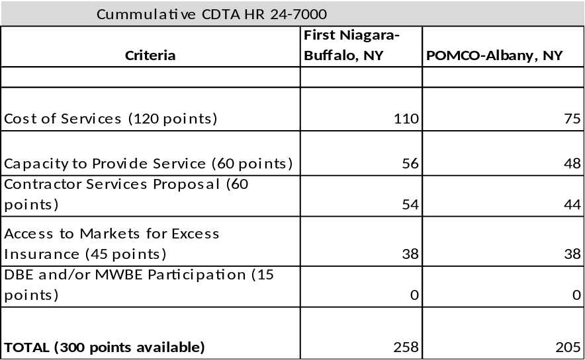
CAPITAL DISTRICT TRANSPORTATION AUTHORITY
Staff Contract Award Certification
1. TYPE OF CONTRACT (check one):
____ Construction & Maintenance _ ___ Goods, Commodities & Supplies ____ Bus Purchase
__X__ Services & Consultants __ __ Transportation & Operational Services

2. TERMS OF PERFORMANCE (check one):
_ ___ One-Shot Deal: Complete scope and fixed value
____ Fixed Fee For Services: Time and materials - open value
__X _ Exclusive Purchase Contract: Fixed cost for defined commodity with indefinite quantity
____ Open Purchase Contract: Commitment on specifications and price but no obligation to buy
____ Change Order: Add on to existing contract

3. CONTRACT VALUE:
__$300,000(years 1-3))_____________________ fixed estimated (circle one)

4. PROCUREMENT METHOD (check one):
_ X___ Request for Proposals (RFP) ____ Invitation for Bids (IFB) ____ Other

5. TYPE OF PROCEDURE USED (check one):
____ Micro Purchases (Purchases up to $2,499.00) ____ Small Purchases ($25,000 up to $$100,000)
____ Sealed Bid/Invitation for Bids (IFB) (Over $100,000) __X __ Request for Proposals (RFP)
____ Professional Services (Over $25,000) ____ Sole or Single Source (Non-Competitive)

6. SELECTION CRITERION USED:
Number of Proposals/Bids Solicited #___24____ or Advertised
Number of Proposals/Bids Received #___2____

Attach Summary of Bids/Proposals
- Disadvantaged/Minority Women’s Business Enterprise (D/MWBE) involvement
Are there known D/MWBEs that provide this good or service? Yes No
Number of D/MWBEs bidding/proposing ____1_(MWBE)_____
D/MWBE Certification on file? Yes No Not Applicable
Number of D/MWBE Subcontractors ____0______

8. LEGAL NAME and ADDRESS OF CONTRACTOR/VENDOR: _First Niagara Risk Management__
_282 Delaware Avenue___________
_Buffalo, NY 14202_____________
9. SOURCE OF FUNDS: ____FY17 Operating Budget_________________________________________

10. COMPLIANCE WITH STATE AND FEDERAL RULES:
Non-Collusion Affidavit of Bidder (Yes, No, N/A)
Disclosure & Certificate of Prior Non-Responsibility Determinations (Yes, No, N/A)
Disclosure of Contacts (only RFPs) (Yes, No, N/A)
Certification with FTA’s Bus Testing Requirements (Yes, No, N/A)

11. RESPONSIBLE STAFF CERTIFIES THE INTEGRITY OF THIS PROCUREMENT/CONTRACT:

__Stacy Sansky, Director of Procurement_____ DATED: __June 1, 2016________________________

Capital District Transportation Authority
Agenda Action Proposal

Subject: Annual Review of Drug and Alcohol Policy

Committee: Performance Oversight
Committee Meeting Date: June 22, 2016
Board Action Date: June 29, 2016

Background:
An annual review of the Drug and Alcohol Policy is required according to 49 CFR Parts 40 & 655 regulations.

Purpose:
The policy must be available to all employees and specifically to employees that perform safety-sensitive functions. The policy ensures that all regulations are up to date and followed to remain in compliance with the Federal Transit Administration.

Summary of Proposal:
There are no required regulatory changes to the Drug & Alcohol Policy. There are minor edit changes in sections IX, X, and XII to provide added clarity, and these changes are highlighted in the policy.

Copies of the Drug & Alcohol Policy changes will be available at the committee meeting.

Financial Summary and Source of Funds:
No impact

Prepared by:
Thomas McKie, Manager of Safety & Training

Project Manager:
Thomas McKie, Manager of Safety & Training



Memorandum

Date: June 22, 2016

To: Carm Basile, Chief Executive Officer

From: Sarah Matrose, Internal Auditor

Subject: Monthly Progress Report – Internal Audit

Below is the Internal Audit monthly progress report covering the time period of May 2016.

- Currently participating in the Supervisor Briefcase program, a seven segment refresher course covering topics including ADA regulations, Drug & Alcohol, Accident Investigation, Security and Workplace Safety.
- Human Resources Benefits Audit Dependent review is underway – audit documents have been mailed to employees for completion
- Drug & Alcohol vendor audit preparation – Capital Land Taxi
- Consulted on the proposed Audit and Drug & Alcohol requirements to be included within the STAR vendor RFP
- Bus Parts Inventory advisory service write-up is in process
- Preparing for the Accounts Receivable audit

The following is a summary of external audit items I have reviewed/performed within the past month.

- Attended an EHA Auditing Webinar Addressing Risk in a Changing World
- Attended an IIA Webinar Preparing for a Successful External Quality Assessment
- Attended a PWC Webinar Internal Audit’s Role in Monitoring and Managing Critical Risks – An Audit Committee Perspective
- Preparations for the Certified Internal Auditor exam

Memorandum

To: Kelli Schreivogl, Director of Human Resources & Safety

From: Tom McKie, Manager of Safety

Date: June 15, 2016

Re: Annual Accident Report – FY2016 vs. FY2015

I am providing a summary of our Annual Accident Report. The report includes a summary of Fiscal Year 2016 accidents and compares it to Fiscal Year 2015. I have included an overview of our total numbers and the accident rate for both years. For informational purposes and because of the nature of this report, I have provided the definition of an accident. An accident is the result of contact between the bus and any object, vehicle, or person.

In FY2016 we had a combined increase of 19 collision and customer accidents over FY2015. The composition of the increase is due to 29 more collision accidents but 10 less customer accidents. Contributing factors of the increase include 400,000 additional revenue miles and 20,000 additional service hours. We have determined that many of the collisions are a result of drivers multitasking, which cause them to be distracted. Common causes include operators answering customer questions; reading paddles; entering data in the radio co-pilot or farebox, and observing people or objects outside the bus for an extended period of time. These issues are addressed in initial, remedial and refresher training when Supervisors instruct the operators on how to combat distractions.

There are nine main categories of collision accidents (see page 3). The highest percentage of preventable accidents occur with bus operators colliding with stationary vehicles or objects. Historically these two categories account for 40% of all collision accidents. However, in FY2016 there was a significant decrease in these two categories of accidents, and the total percentage was reduced to 20%. Total customer accidents fell slightly in FY2016 with on-board accidents decreasing and boarding accidents showing a small increase.

At the end of the report, I have provided an activity summary of the variety of training programs conducted in FY2016.

Type | FY2016 | FY2015 | Difference
Total Collision & Customer Accidents | 505 | 486 | +19
Accident Rate per 100k miles | 4.98 | 4.96 | +.02

Note: 20,000 Service hours and 400,000 miles were added in FY2016

COLLISION ACCIDENTS
YEAR | NUMBER OF ACCIDENTS | INCREASE/  DECREASE FROM PREVIOUS YR. | NUMBER PREVENTABLE | ACCIDENT  RATE PER  100,000  MILES | ACCIDENT RATE PER  100,000 BOARDINGS
FY16 | 337 | +29 | 137 | 3.32 | 1.96
FY15 | 308 |  | 136 | 3.14 | 1.81

CUSTOMER ACCIDENTS
YEAR | NUMBER OF ACCIDENTS | INCREASE/  DECREASE FROM PREVIOUS YR. | NUMBER PREVENTABLE | ACCIDENT RATE PER 100,000  MILES | ACCIDENT RATE PER 100,000  BOARDINGS
FY16 | 168 | -10 | 32 | 1.66 | .98
FY15 | 178 |  | 30 | 1.81 | 1.04

TOTAL ACCIDENT COMPARISON
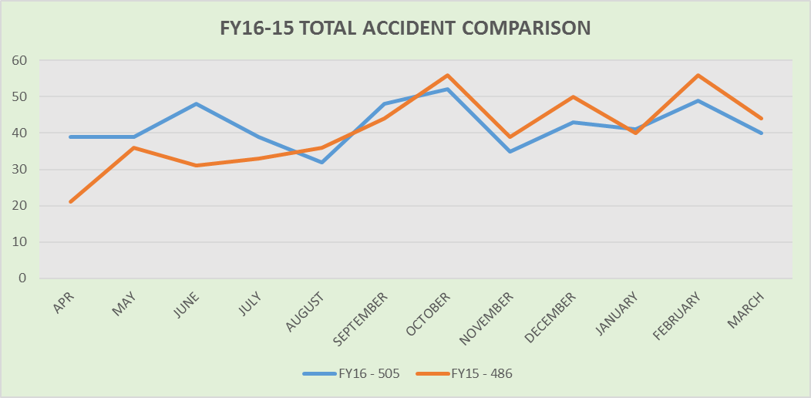

PREVENTABLE ACCIDENTS

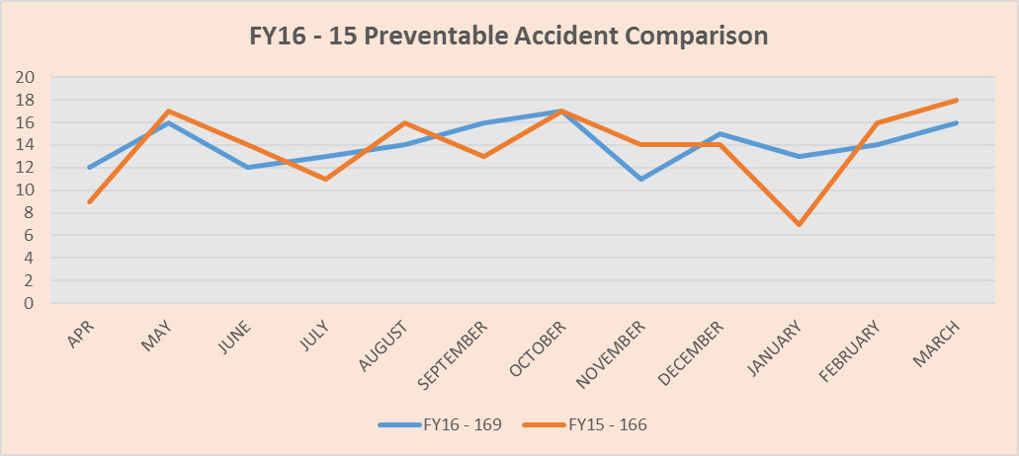

FY16 PREVENTABLE ACCIDENTS BY CATEGORY

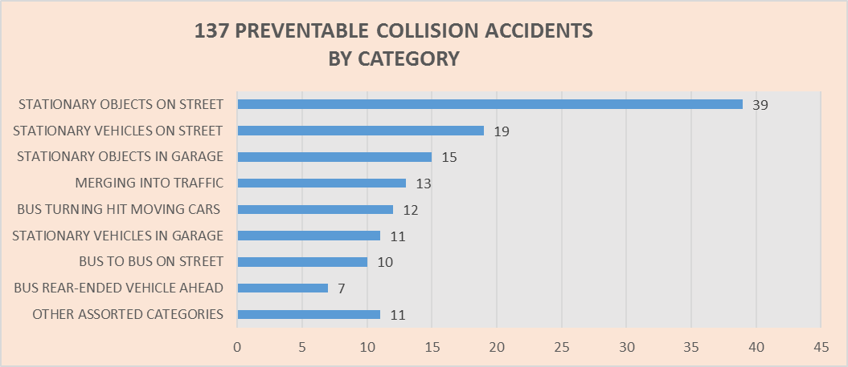

COLLISION ACCIDENTS
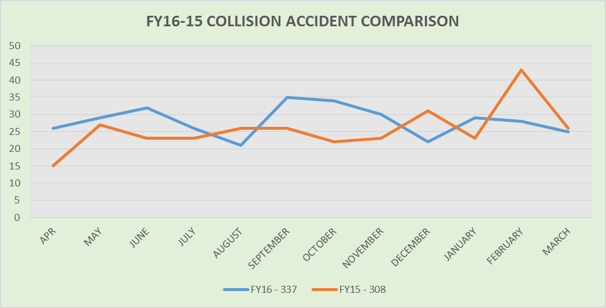

CUSTOMER ACCIDENTS
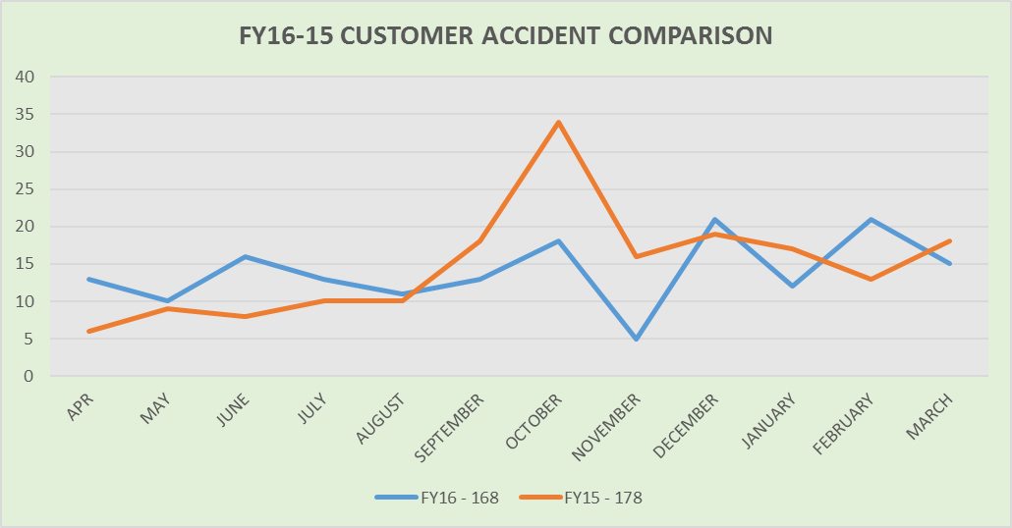

Safety & Training Activity Summary for FY 2016
- Trained 65 new operators
- Trained 12 Service Techs for CDL License
- Performed 73 remedial trainings
- Performed 42 post accident on-board observations
- Performed 22 return to work refresher trainings
- Completed 19-A Requirements
  - 351 Annual Interviews
  - 176 Behind the Wheel Road Tests
  - 344 Defensive Driving Observations
  - 191 Written/Oral knowledge Tests

We continue to bring new operators back for refresher training within their first month of operation to discuss how to prevent the types of collisions that new operators are having; to obtain feedback on how well training has helped, or not helped cope with the pressures of schedules and inexperience; and to solicit ideas on how initial training can change to improve the overall training program.
cc: Mike Collins
Rich Cordero

